Indirect effects of soil amendments on plant traits and the microbiome in post-wildfire forest recovery

^{1,5}David M. Barnard, ¹Adam L. Mahood, ¹Jacob A. Macdonald, ²Kaela K Amundson, ^{2,3}Timothy S. Fegel, ¹Sean M. Gleason, ¹Madeline Guimond, ⁴Sophia Kaiser, ²Kya Sparks, ²Michael J. Wilkins, ³Charles C. Rhoades

¹USDA Agricultural Research Service, Water Management and Systems Research Unit, Fort Collins, CO, 80526
²Department of Soil and Crop Science, Colorado State University, Fort Collins, CO 80523
³US Forest Service, Rocky Mountain Research Station, Fort Collins, CO 80526
⁴Harvard University, Extension School, Sustainability Program, Cambridge, MA 01238
⁵Corresponding author: david.barnard@usda.gov

Corresponding author permanent address:
David Barnard
2150 Centre Ave, Building D
Fort Collins, CO, 80526

Abstract
Increasing wildfires across the western United States are affecting forest resilience, often leading to novel ecosystems after forest regeneration failures. Following fire, soil organic amendments are commonly applied to reduce erosion and accelerate recovery, but treatment effects on vegetation functional strategies and plant-microbe interactions are poorly understood. Here, we assess the impacts of soil amendments on plant and microbial community composition and plant functional traits 13 years following a severe wildfire in Colorado. Treatments included woody mulch, biochar, and mulch + biochar, which had unique effects on soil nutrients, chemistry, moisture, and microbiomes. We considered three plant functional traits: plant height, specific leaf area (SLA), and leaf dry matter content (LDMC), which had limited differences among treatments. Random forests revealed multiple non-linear relationships between plant traits and soil characteristics, but not treatment cover. However, exploratory mediation showed indirect effects of treatments through changes to soil physical and chemical properties and microbial composition. There was a species-specific response of plant traits to soil N form; Vaccinium scoparium responded more to NH₄⁺ and Oreochrysum parryi responded more to NO₃⁻. Interactions among soil moisture, chemistry (pH and cations), and microbiome composition (especially ectomycorrhizal fungi and nitrifying bacteria and archaea) drove variation in plant traits. These findings show that soil amendment effects on plant traits or microbial composition may not be directly detected using simple statistical approaches, but emerge as non-linear or indirect effects, revealing the multifaceted importance of soil biotic and abiotic characteristics. This work will benefit future research and restoration practices utilizing a trait-based approach to ecosystem recovery and improving forest resilience.

Keywords: mulch, biochar, plant functional traits, wildfire, soil amendments, soil microbiome

1. Introduction
Wildfires are becoming more frequent and severe across western North America, with important implications for forest resilience, soil erosion, and water resources (Abatzoglou and Williams, 2016; Barnard et al., 2023; Kampf et al., 2022). High-severity fires, in particular, affect forest function and ecosystem services by burning vegetation and altering biogeochemical cycling through changes to soil structure, chemical properties, and the microbiome (Caiafa et al., 2023; Nelson et al., 2022). Although many forests across the West have historically experienced stand-replacing fires, the increasing frequency and severity of wildfires combined with a warmer and drier climate can alter vegetation structure and function, especially as regeneration failures increasingly lead to ecosystem state changes (Harvey et al., 2016; Roccaforte et al., 2012; Rother et al., 2015; Stevens-Rumann and Morgan, 2019). Understanding the functioning of the recovering vegetation and restoration treatment effects using an approach that considers plant traits (trait-based approach) is especially important for forecasting future forest resilience and the recovery of ecosystem services after disturbance (Aubin et al., 2024; Suding, 2011).
Changes to soil properties, nutrient losses, and subsequent impacts on vegetation recovery are a major concern after wildfire (Bormann et al., 2008; Certini, 2005; Homann et al., 2011). Fires leave behind nutrient-rich ash that is susceptible to erosion (Ebel, 2012; Santín et al., 2015) and alter pools of soluble nutrients, such as nitrogen or phosphorus, which are prone to leaching (Wan et al., 2001). Moreover, high soil temperatures during fire reduce microbial biomass and diversity post-fire (Nelson et al., 2022; Pressler et al., 2019), which can affect short-term N cycling (Dove et al., 2020). Restoration treatments, such as organic soil amendments, are often applied after high-severity fire, primarily to reduce soil erosion (Prats et al., 2016; Robichaud et al., 2017), but may also improve vegetation recovery and soil fertility and retain moisture (Fornwalt et al., 2017; Jonas et al., 2019; Kaiser et al., 2025; Rhoades et al., 2017). Common organic amendments include wood-strand mulch (hereafter “mulch”) and biochar. By increasing surface cover, mulch can reduce runoff and erosion, improve infiltration and soil moisture, and limit nitrogen losses (Bautista et al., 2009; Rhoades et al., 2025). Biochar, a form of pyrogenic carbon with a high surface area and exchange capacity, can further retain moisture and nutrients (Rhoades et al., 2017). Both mulch and biochar have been shown to improve soil moisture, microbial diversity, plant establishment, and nutrient retention (Fornwalt et al., 2017; Jonas et al., 2019; Kaiser et al., 2025; Rhoades et al., 2017).
Previous studies quantifying the effects of post-fire organic soil amendments on vegetation recovery across the western US have focused mostly on vegetation composition and structure (Bontrager et al., 2019; Carmona-Yáñez et al., 2023; Fornwalt et al., 2017; Jonas et al., 2019; Kaiser et al., 2025; Ortega et al., 2022). However, there is an increasing need to consider trait-based approaches to understand functional plant responses relevant to restoration projects and ecosystem recovery (Aubin et al., 2024). Plant functional traits can, for example, predict plant fitness, key processes of community assembly, and serve as guides for which subsets of species pools may thrive in a given location after disturbance (Brudvig and Mabry, 2008; McGill et al., 2006). Plants, in general, adapt to resource availability by selecting among growth strategies that tolerate stress (i.e., slower growth, more stress-resilient anatomy), or avoid stress (i.e., faster growth, shorter life-cycle)(Wright et al., 2004). In reality, plant functional responses fall somewhere on a continuum between these two seemingly opposite strategies, resulting in traits that integrate among various environmental and biological signals (Gleason et al., 2018; Reich, 2014; Wright et al., 2004). Species and ecosystems may also recover with changes to inter- and intra-specific trait variability, where greater variability may be beneficial by improving ecosystem-level resilience to a range of biotic and abiotic filters and environmental changes (Henn et al., 2018; Jung et al., 2010). Post-fire soil amendments add a layer of unexplored complexity regarding where, and with what variability, plant functional strategies may emerge on this continuum in recovering vegetation. For example, species that resprout from rootstock after fire have been shown to have higher specific leaf area (SLA) than species that regenerate by seed (Anacker et al., 2011).
There are numerous plant traits that can be used to infer functional strategies, all of which are defined by a capacity to integrate across physiological, anatomical, and phenological responses to resource availability and environmental signals (Perez-Harguindeguy et al., 2016). These traits can be collected from roots, stems, or leaves, or the whole plant, but leaf traits are most common due to ease of measurement and interpretability. Three prominent functional traits are plant height, SLA, and leaf dry matter content (LDMC). Height captures whole-plant responses to resource availability and environmental signals, while SLA and LDMC capture leaf-level responses (Niklas et al., 2023; Westoby and Wright, 2006). SLA (leaf area divided by oven-dried leaf mass) typically increases in environments where greater leaf expansion and growth rates are supported by abundant resources. On the other hand, LDMC (oven-dried mass divided by water-saturated mass) typically increases as environmental stressors, such as wind or aridity, combine with low resource availability to promote the development of longer-living and mechanically robust leaves (Blumenthal et al., 2020; Ocheltree et al., 2020) with higher cellulose and lignin concentrations. Quite often, LDMC and SLA are inversely related within-species, with the shape of the relationship reflecting environmental gradients, disturbance history, and resource availability (Perez-Harguindeguy et al., 2016). Both traits can also vary substantially among species in an ecosystem due to plant life-cycles, growth forms, and life strategies (e.g. drought-escape versus drought-avoidance) (Blumenthal et al., 2020; Wright and Francia, 2024).
In 2010, the Church’s Park fire burned 200 hectares of lodgepole pine (Pinus contorta) forest northwest of Fraser, CO. Lodgepole pine is a key forest species across western North America with a wide but declining distribution (Stanke et al., 2021). In June of 2014 research plots were established to investigate the impacts of organic soil amendments (mulch, biochar, mulch + biochar) on soil moisture and nutrients (Rhoades et al., 2017). The goal of the current study was to revisit these sites thirteen years after the fire and nine years after soil amendment applications to resample soil moisture and nutrients, and collect additional measurements of vegetation community, soil microbial communities, and plant functional traits. We selected two abundant plant species based on an assumption that different life-history and growth strategies would yield different trait responses to treatments: Parry’s goldenrod (Oreochrysum parryi) a basal-sprouting perennial forb which reestablishes via seed after fire, and grouse whortleberry (Vaccinium scoparium) a deciduous shrub which resprouts from rhizomes after fire. Our overarching goal was to quantify the impact of organic amendment treatment on vegetation recovery in terms of changes to community composition and plant functional traits while accounting for effects of landscape position, soil moisture, nutrients, and microbial community. However, we approached this analysis under the assumption that treatment effects may be observed directly (univariate relationships, potentially non-linear), or indirectly via mediators. To our knowledge, no single analytical approach can account for non-linearity and direct versus indirect effects, especially on smaller datasets with many predictors relative to observations. Thus, we employed a multifaceted analytical approach using random forests to identify key predictors and non-linear relationships, and exploratory mediation to perform feature selection and identify indirect effects. With this analytical approach we sought to answer three main research questions: 1) how do organic soil amendments affect vegetation recovery in terms of plant functional traits and plot-level plant and soil microbial communities? 2) Are univariate relationships of dependent variables in response to predictors and potential mediators non-linear? And, 3) can indirect effects of treatments and landscape position be identified through mediator variables?

2. Methods

2.1. Study site and statistical design
For this study, we revisited experimental plots within the Church’s Park burn perimeter established in 2014 (Rhoades et al., 2017). The Church’s Park fire burned 200 hectares from 2438 to 3200 m elevation. 47% of the total area was burned at moderate to high severity and 53% at low severity (USFS, 2010). This area of Colorado receives on average 700 mm of precipitation annually, primarily as snow during the winter and spring, with sporadic convective rainstorms during the monsoon season in late summer (NRCS, 2013). Soils at the research sites are characterized by gravelly, sandy-loam Alfisols from alluvium and colluvium of granitic gneiss and schist parent materials (Alstatt and Miles, 1983). Prior to the fire, forest overstory was primarily lodgepole pine with scattered stands of quaking aspen (Populus tremuloides) (Huckaby and Moir, 1998). In the mid- to late-2000s, before the fire, an infestation of mountain pine bark beetles (Dendroctonus ponderosae) killed >85% of the overstory trees (Chapman et al., 2012).
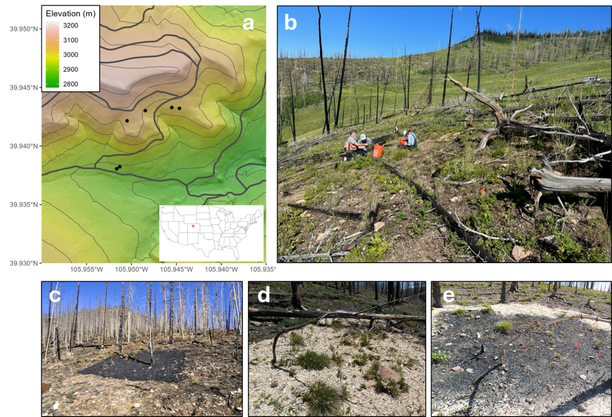
Figure 1: Site map of experimental plots (a), site at 12 years post-fire showing minimal forest recovery (b), examples of treatments immediately after amendment application for biochar (c), mulch (d), and mulch + biochar (e). In panel a, grey lines represent dirt roads, black points are the study blocks, grey contour lines represent elevation increments of 50 m. For panel b note this image was take in June 2023, 13 years after the Chruch’s Park fire, panels c-e were taken immediately after amendment application in 2014. Photo credits: D.M. Barnard (b) and C.C. Rhoades (c-e).

A full description of the study design to test soil amendment effects is available in Rhoades et al (2017). Briefly, organic treatment impacts were quantified on soil chemistry, nutrients, and physical properties and re-establishment of vegetation in areas that burned at high severity. The study design consisted of six blocks, each with four 5 x 5 m plots within a small area of the burn perimeter (Fig. 1c-e). The block locations were selected to include areas that had similar forest composition before the fire based on the following criteria: (1) >75% lodgepole pine with (2) >85% beetle mortality, (3) slope angles between 5-15%, (4) south-facing aspect. Within each block, plots were randomly assigned to one of four treatments: mulch, biochar, mulch + biochar, and control. The biochar used in this study was created through pyrolysis of local lodgepole pine chips at 400-550 degrees C and then applied at 20 t ha⁻¹ and raked into the top 2-3 cm of mineral soil (Fig. 1c). The mulch was also chipped from local lodgepole pine and applied to create a 2 cm deep layer on the soil surface (equivalent to 37 t ha⁻¹)(Fig. 1d). In the combined treatment, mulch was applied on top of the biochar, with similar application methods and rates as for the individual mulch and biochar treatments (Fig. 1e). A trench was dug on the uphill side of each block to reroute surface runoff so as to not affect the cover of the organic treatments.

2.2. Field data collection

2.2.1. Soil moisture, nutrients, and chemistry
We measured soil volumetric water content (VWC) monthly from June to September in each plot in the upper 15 cm of soil using a hand-held, time-domain reflectometry probe (HydroSense II, Campbell Scientific, Logan, UT). In each plot at every sampling date, five readings were collected at intervals equally spaced on a line crossing the middle of each plot. To omit influences from surface litter and mulch, all material was carefully moved aside prior to collecting VWC measurements. Full VWC data are reported in Kaiser et al (2025). For this study, we focused only on June VWC measurements because field observations indicated that leaves for both species had fully expanded by then and thus later VWC measurements would not be indicative of leaf development.
Soil samples were collected from each plot to characterize soil physical, chemical, and nutrient characteristics. Prior to soil sampling, any organic material, remnant mulch, and organic horizon was removed, and underlying mineral soil was collected at depths of 0-5 cm and 5-15 cm twice in each plot using a 6.4 cm diameter bulb corer that was sterilized between samples. The two samples from each depth were then combined. Roots and rocks were removed from samples in a sterile lab setting. One subsample was dried, sieved, and ground for total C and N analysis via dry combustion and infrared detection (CN 802, Velp Scientifica, Deer Park, NY). Soil pH was assessed using a 1:1 soil-to-water slurry after one hour of agitation (Thomas, 1996; inMotion Pro, Mettler Toledo, Greifensee, Switzerland). Another subsample was taken to quantify water-soluble ions, nutrients, and C by shaking the sieved soils with deionized water (> 18 MΩ), filtering, and analyzing for dissolved organic C (DOC) and total dissolved N (TDN) after purging mineral carbon with HCl (Shimadzu Co., Columbia, MD). Detection limits for water-extractable DOC and TDN were <0.05 mg L⁻¹ and <0.01 mg L⁻¹, respectively. Water soluble ions were determined by ion chromatography using electrical conductivity detection with an AS19A column for anions and CS12A column for cations (Integrion, Thermo Fisher, Waltham, MA). Detection limits for water-extractable ions were <0.01 mg L⁻¹ for Na⁺ ,K⁺, Na⁺, Ca⁺², Mg⁺², NH₄⁺-N, NO₃⁻-N, SO₄⁻, and PO₄. Dissolved inorganic N (DIN) is then defined as the sum of NO₃⁻-N and NH₄⁺-N. Soil texture was measured by standard methods using a Bouyoucos hydrometer (Gee, 1986). Cations were grouped as a modeling predictor using the sum of Na⁺ ,K⁺, Na⁺, Ca⁺², and Mg⁺² concentrations.

2.2.2. Microbial sampling
Soil samples were collected to characterize microbial community and functional groups using the same protocol described above for soil nutrient and chemistry analyses. Samples were placed in sterile Whirlpak bags and stored at 4 ºC during transport before being placed in in a -80 ºC freezer until processing. Microbial DNA was extracted using Zymo Research Quick-DNA Fecal/Soil Microbe kit according to the manufacturer’s instructions. Archaeal/bacterial communities were characterized by sequencing the V4 region of the16S rRNA gene (Apprill et al., 2015; Parada et al., 2016) using the Earth Microbiome Project (EMP) suggested primers of 515F and 806R, while fungal communities were profiled using the first internal transcribed spacer (ITS1) sequencing (White et al., 1990). To process the reads, we used QIIME2 (2021.2) and discarded low-quality ITS reverse reads. Demultiplexed 16S and ITS samples were merged, filtered, denoised, and binned to create amplicon sequence variants (ASVs) with DADA2. The read counts for 16S rRNA ranged from 20,952 to 68,942, while ITS counts varied from 9,875 to 206,218. Bacterial and archaeal ASVs were taxonomically classified using pre-trained SILVA (version 138: Quast et al., 2012; Robeson et al., 2021) classifiers, and fungal ASVs were classified with self-trained UNITE (version 9.0: Nilsson et al., 2019) database classifiers. Sequences not assigned to the appropriate kingdoms and ASVs classified as mitochondria or chloroplasts were discarded. The resulting reads were deposited in NCBI under BioProject PRJNA682830.

2.2.3. Plant community and trait sampling
In August 2023, we measured substrate and plant cover at peak herbaceous biomass. Cover of each species was measured within two, 1 m² quadrats per 5 m² plot (48 quadrats total) using a gridded point intercept method. We measured three plant functional traits, canopy maximum height (hereafter, ‘height’), LDMC and SLA, for four individuals at each plot for two species that were abundant throughout the study area, O. parryi, a native perennial forb and V. scoparium, a native deciduous shrub (n=96 per species). For each plant sampled, height was measured, and then the plant was clipped at ground level and placed in a pitcher of deionized water. The cut surface was immediately submerged, and the stem was cut again approximately 1 cm from the original cut with a sharp razor blade. While the cut was still submerged, the base of the stem was placed in a Falcon tube filled with deionized water. Plant samples were returned to the lab to rehydrate for 24 hours. Then, fully hydrated leaves were clipped from the stem and weighed, scanned with a flatbed scanner at 600 dpi along with a red 2x2 cm square, dried in a drying oven at 70 degrees Celsius for 72 hours, and then weighed again. Image processing software Image J (Schneider et al., 2012) was used to calculate leaf area. Each image was converted to greyscale, and individually thresholded until the leaves were fully highlighted, using a threshold between 150-190. A 2 x 2 cm square scanned with the leaves was used to set the scale for the leaf area in Image J. Total leaf area was then calculated in cm² by the software. LDMC and SLA were calculated as:

 | $$LDMC = \frac{Md}{Mw}* 1000$$ | (1)

 | $$SLA = \frac{Md}{LA}$$ | (2)
Where Md is the oven-dried sample mass in mg, Mw is the rehydrated wet sample mass in g, and LA is the rehydrated leaf area in m².

2.3. Topographic data
Topographic attributes of each study block were calculated from a 10 m² digital elevation model (DEM; Rabus et al., 2003). We calculated slope from the DEM using the terra R package (Hijmans et al., 2022). We calculated folded aspect (McCune and Keon, 2002) and topographic wetness index (TWI; Beven and Kirkby, 1979) using the topomicro R package (Mahood, 2024). Folded aspect is an index of how southwesterly a surface is, with low values being cold, northeast-facing aspects, and high values being closer to a warmer, southwest-facing aspect. Topographic wetness index is an indicator of how much water will drain to a given point and is calculated based on how much land area is upslope of that point.

2.4. Statistical analysis
Logistical constraints on study design and sampling produced a relatively small sample size of dependent variables, but a large number of predictors. Approaches to analyzing and interpreting such datasets can become unwieldy using standard one-off approaches or possibly generate statistically significant but misleading results. To address these potential shortcomings, we used a multi-faceted approach to data analysis that included (1) analysis of variance, means testing, and linear regression to assess statistical differences among treatments, (2) ordinations to assess plant and microbial community composition and multivariate soil characteristics among treatments, (3) random forests Breiman, 2001to visualize non-linear univariate relationships between predictors and dependent variables and potential mediator variables, and (4)Lefcheck, 2016 exploratory mediation to identify indirect effects of mediators between independent and dependent variables. All statistical analyses were done in R (Team, 2021).

2.4.1 Ordinations of microbial and plant community composition, and soil chemistry
To quantify plant community composition, and how it responded to treatments, we performed a non-metric multidimensional scaling ordination (NMDS) (Minchin, 1987) on the species occurrence data averaged for each plot and used a PERMANOVA (Anderson and Santana‐Garcon, 2015) to test the effect of sample year and treatment effects on community composition. To visualize how the treatments affected the microbial community composition, we performed an NMDS ordination on the microbial community matrix for both abundance and occurrence data in both sampling depths (0-5 and 5-15 cm). Finally, we ran a principal components analysis on all soil chemistry variables measured.
To complement the PERMANOVA analysis for treatment effects on the bacterial and fungal community composition, we performed a beta dispersion analysis to examine if variability within treatment groups drive significant differences in our ordinations. We used the betadisper function, which is a multivariate equivalent to Levene’s test in the vegan package in R (Dixon, 2003). ITS sequences were linked to fungal guilds using the FUNGuild database (Nguyen et al., 2016), and individuals were grouped into the ectomycorrhizae functional group. To assess discriminant taxa between soil treatment groups, we performed a statistical analysis using the MaAsLin2 R package (Mallick et al., 2021). Putative nitrifiers were classified based on matching sequence taxonomy to known nitrifying bacteria and archaea. Microbial Shannon’s H alpha diversity between soil depths and treatments was assessed using pairwise Wilcoxon signed-rank tests with Bonferroni p-value adjustments in the ggpubr and stats package (Kassambara, 2018). Microbial beta diversity was calculated using Bray-Curtis dissimilarity matrices, and treatment effects were tested using nonparametric permutational multivariate analysis of variance (PERMANOVA) (Anderson and Santana‐Garcon, 2015). Both analyses were completed using the R vegan package (Oksanen et al., 2007).

2.4.2. Random forest models
Random Forests excel at capturing complex, non-linear relationships between variables (Breiman, 2001), which makes them particularly effective for analyzing plant functional traits and microbial responses to soil, treatment, and microbial predictors. For plant traits, soil predictors were averaged across both sampling depths to represent bulk conditions and account for unknown variations in rooting depth and distribution. For microbial analyses, we ran separate random forest models with both the dependent variables and predictors stratified by sampling depth, and a third with measurements from both depths averaged together. Random forest models were trained on the dataset using the randomForest package in R (Breiman et al., 2018). There were isolated instances of collinearity among predictors (Fig Sx), primarily between fungal diversity and PO4 and DIN and NH4. Preliminary testing showed no discernable difference in random forest results whether colinear predictors were included or filtered out, so we proceeded with further modeling using the whole dataset. Hyperparameters were fixed at 5000 individual trees in each model and the number of predictors assessed at each branch was defined as the square-root of the total number of predictors. We then estimated variance explained for each model using a linear regression between observed and predicted data.

2.4.3. Exploratory mediation for indirect effects
To quantify potential indirect effects of treatments on plant traits and microbial composition, we used regularized variable selection and exploratory mediation using the ‘regsem’ package in R (Jacobucci, 2017). We selected exploratory mediation over traditional structural equation models because it includes a feature selection process and reduces model overfitting in smaller datasets that have a large number of predictors. This is accomplished by using regularization to shrink parameter estimates therefore improving model stability and generalizability with smaller datasets. We used Elastic Net (Enet) regularization as it is ideal for datasets like ours with a large number of predictors, some of which may be correlated, with a smaller number of observations (Zou and Hastie, 2005). The ENet regularization is an ideal compromise between Lasso and Ridge regularization as is balances feature selection (Lasso L1 penalty) and coefficient shrinkage (Ridge L2 penalty) to ensure the most relevant predictors are retained while reducing overfitting and multicollinearity. To bring further defensibility to indirect effect estimates from our smaller dataset, we used 10-fold cross-validation and models were bootstrapped (1000 iterations) to estimate 95% confidence intervals and ensure stability of indirect effect sizes. To assess indirect effects on plant function traits, we ran two exploratory mediation models, one with mulch and biochar cover as independent variables (to assess treatment effects) and a second with TWI and soil clay content (to assess landscape effects). The plant traits models included all soil chemical, physical, and microbial variables as potential mediators. We ran two other models

Lefcheck, 2016
Bates, 2014Lefcheck, 2016Murphy, 2024

3. Results

3.1 Vegetation dynamics and soil chemistry thirteen years after fire
Thirteen years after fire and nine years after soil amendment treatments, there was little evidence of lodgepole pine regeneration (Fig. 1b), and the understory plant community did not differ among treatments (Figs. 2, S1). Exotic plant cover was low (< 1%) and was not significantly affected by treatment. (Kaiser et al., 2025)2017Mulch treatments were associated with lower relative abundances of ectomycorrhizal fungi and putative nitrifiers, and higher VWC and PO₄⁺ (Fig. S3). Across treatments, NO₃⁻ comprised ~90% of DIN, was lowest in the 0-5 cm soil samples in plots with biochar (6 and 8% for biochar and biochar + mulch, respectively), was highest (22%) at the 5-15 cm depth in the mulch treatments and was ~10% for the remaining treatments. Total dissolved N was mostly inorganic N forms, with DIN making up 8-46% of TDN, highest in biochar treatment, and lowest in the control treatment.
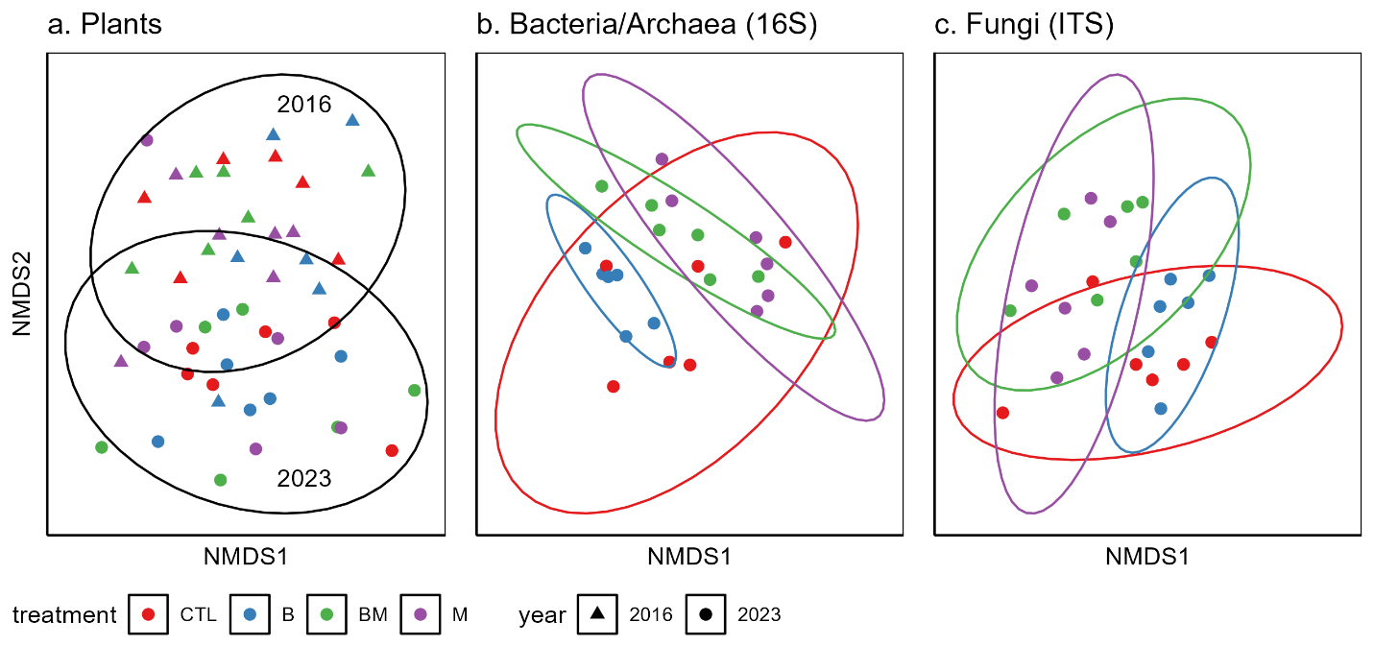
Figure 2. Treatment and year effects on the plant community (a), treatment effects on bacterial/archaeal (b) and fungal (c) communities in 2023 at 0-5 cm depths.

3.2. Direct treatment effects on plant functional traits
Plant functional traits varied inconsistently among species and treatments (Fig. 3). There was less variability within treatments (intraspecific variation) than among species (interspecific variation) for LDMC, with the converse being true for SLA and height. All three traits exhibited similar levels of intraspecific trait variation among the two species. The coefficient of variation for LDMC was 10.6% for O. parryi and 11.9% for V. scoparium; for SLA it was 18.2% for O. parryi and 17% for V. scoparium; and for plant height it was 26.6% for O. parryi and 32.1% for V. scoparium. A two-way ANOVA indicated there were no differences between species means for SLA and height (p=0.16, and p=0.24, respectively), but LDMC was significantly higher in V. scoparium (p < 0.001). When accounting for species, a treatment effect was only observed in SLA between control and mulch plots (p = 0.023, Tukey’s pairwise comparison). There was a significant interaction term (p < 0.01) between species and treatment for height, indicating the relationship between treatment and height varied between the V. scoparium and O. parryi. We then performed linear regression tests to assess relationships between plant traits to capture resource utilization tradeoffs. We only found significant linear relationships between LDMC and SLA; p < 0.001, R² = 0.21, and p < 0.001, R²=0.43 for V. scoparium and O. parryi, respectively.
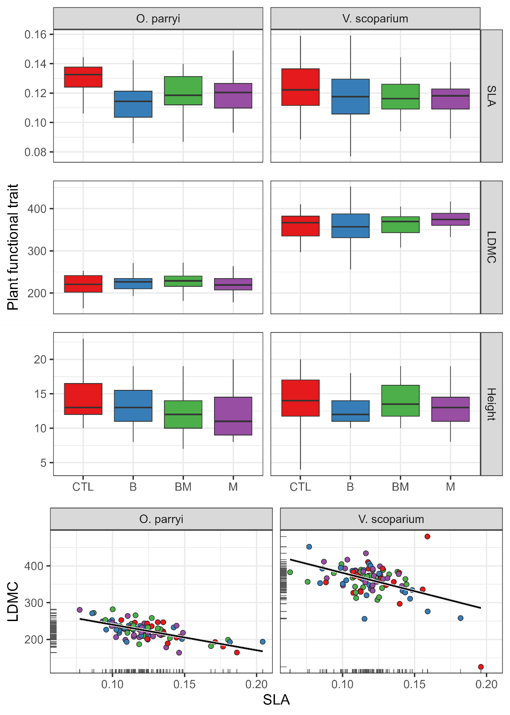
Figure 3: Variation in plant traits among species and organic soil amendment treatments (a), and correlations between specific leaf area (SLA) and leaf dry matter content (LDMC) in two species.

3.3. Random forests of plant traits and microbial community composition
Key differences in predictor importance, effect sizes, and effect shapes were evident between species and among plant functional traits (Fig. 4). Model performance was decent among all species and traits (R² > 0.34) except for LDMC in V. scoparium (R² = 0.01; Table 1). Traits from both species were driven largely by soil chemistry, with divergent responses between the species, and SLA and LDMC response shapes typically being inverted between species. Oreochrysum parryi was strongly affected by NO₃⁻ with threshold-like responses that were inverse for SLA and LDMC, and similar threshold-like responses to CN and DIN. On the other hand, V. scoparium was driven more by NH₄⁺, especially height and with SLA and LDMC showing similar inverse responses as O. parryi to NO₃⁻. Across all traits and species, NO₃⁻ was the strongest predictor overall with an average relative importance score of 0.65, followed by bacterial/archaeal Simpson diversity (0.49), NH₄⁺, DOC, and percent clay (all 0.39). Interestingly, NO₃⁻ remained the strongest predictor of trait variation when both species were pooled, but the explanatory strength of NO₃⁻ was stronger in O. parryi, whereas NH₄⁺ was a stronger predictor in V. scoparium, indicating a potential species-level preference for specific forms of N or the associated microbes that affect them. This is further confounded by microbial nitrifiers having a much stronger effect in V. scoparium compared to O. parryi. Mulch and biochar cover had limited explanatory power except for with height in O parryi. Microbial predictors were also variable in shape and effect size across traits and species. For example, Simpson’s diversity of bacteria/archaea was an important predictor for O. parryi, with height and SLA decreasing with increasing diversity, and LDMC increasing with diversity. The relative abundance of EMF was less important than expected with threshold-negative responses to height in O. parryi and LDMC and SLA in V. scoparium.
Random forest model performance for microbial variables differed between soil depths in the two diversity metrics, being stronger in the 0-5 cm depth, but was still quite strong in the model with the two depths pooled (R² > 0.7; Table 1). Hence, for simplicity, we’ll refer to results of the pooled model of microbial groups for the remainder of this paper.
There was little consistency in which predictors were most important among microbial groups, but there was much consistency in threshold-like and stepped response shapes (Fig. 5). Overall, EMF and nitrifiers showed the greatest percent variation among samples (>100 and 25%, respectively), with fungal and bacteria/archaeal diversity showing minimal variation (0.2 and 0.5%, respectively). Biochar and soil pH were strong predictors, with both EMF and nitrifier abundance increasing non-linearly with residual biochar cover, but with opposite effects of pH. Variability in EMF was most strongly affected in a positive, but threshold-like manner, by NO₃⁻, nitrifiers by biochar, bacteria/archaeal diversity by VWC, and fungal diversity by PO₄⁺and cations. Treatments had direct effects on EMF and nitrifier relative abundance (biochar and mulch, respectively), and mulch on fungal diversity.
Table 1: Random forest model performance determined as the R² from a linear regression fit to predicted versus observed data for the dependent variables. Microbial random forests were run for each soil sampling depth and with values pooled across samples. Plant trait random forests were only run on the pooled depths.

 | Trait | R² 0-5 cm | R² 5-15 cm | R² pooled depths
V. scoparium | SLA | - | - | 0.37
 | LDMC | - | - | 0.01
 | Height | - | - | 0.46
O. parryi | SLA | - | - | 0.46
 | LDMC | - | - | 0.34
 | Height | - | - | 0.37
Microbes | EMF relative abundance | 0.94 | 0.87 | 0.71
 | Nitrifier relative abundance | 0.92 | 0.92 | 0.78
 | Archaeal/Bacterial diversity | 0.96 | 0.14 | 0.83
 | Fungal diversity | 0.93 | 0.19 | 0.78

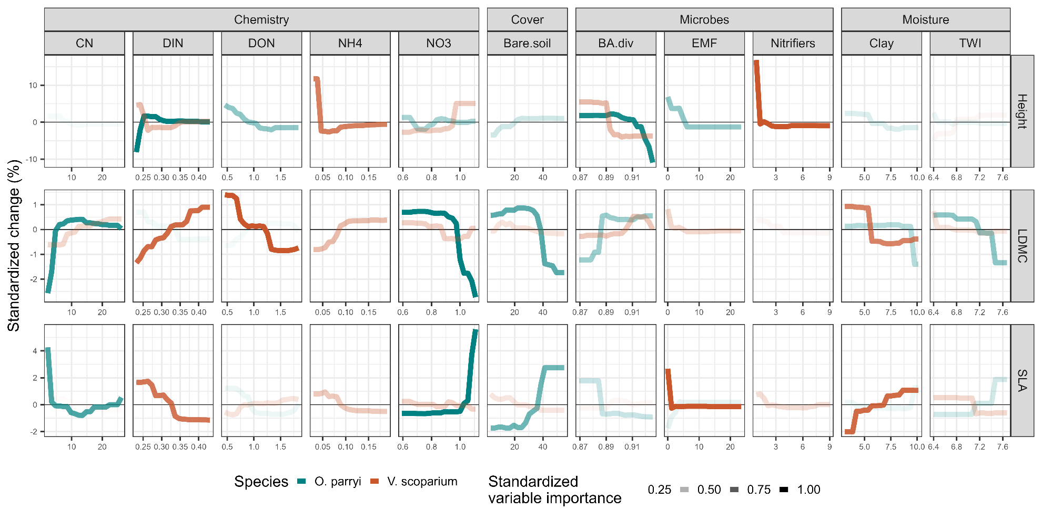
Figure 4: Random forest partial dependence plots show the effect sizes and shapes of responses of plant functional traits to the 11 most important predictors. For visual clarity among species, the y-axis shows a standardized percent change from the mean of each functional trait. Similarly, the transparency of each line represents the standardized variable importance score for each predictor in each species, calculated as the increase in node purity for each predictor within a model, divided by the increase in node purity of the most important predictor, i.e. the darker and less transparent a line, the more important the predictor. Acronyms: total carbon:nitrogen (CN), dissolved inorganic nitrogen (DIN), dissolved organic nitrogen (DON), ammonium (NH4), nitrate (NO3), bacterial and archaeal diversity (BA.div), ectomycorrhizal fungi (EMF), topographic wetness index (TWI), leaf dry matter content (LDMC), and specific leaf area (SLA).
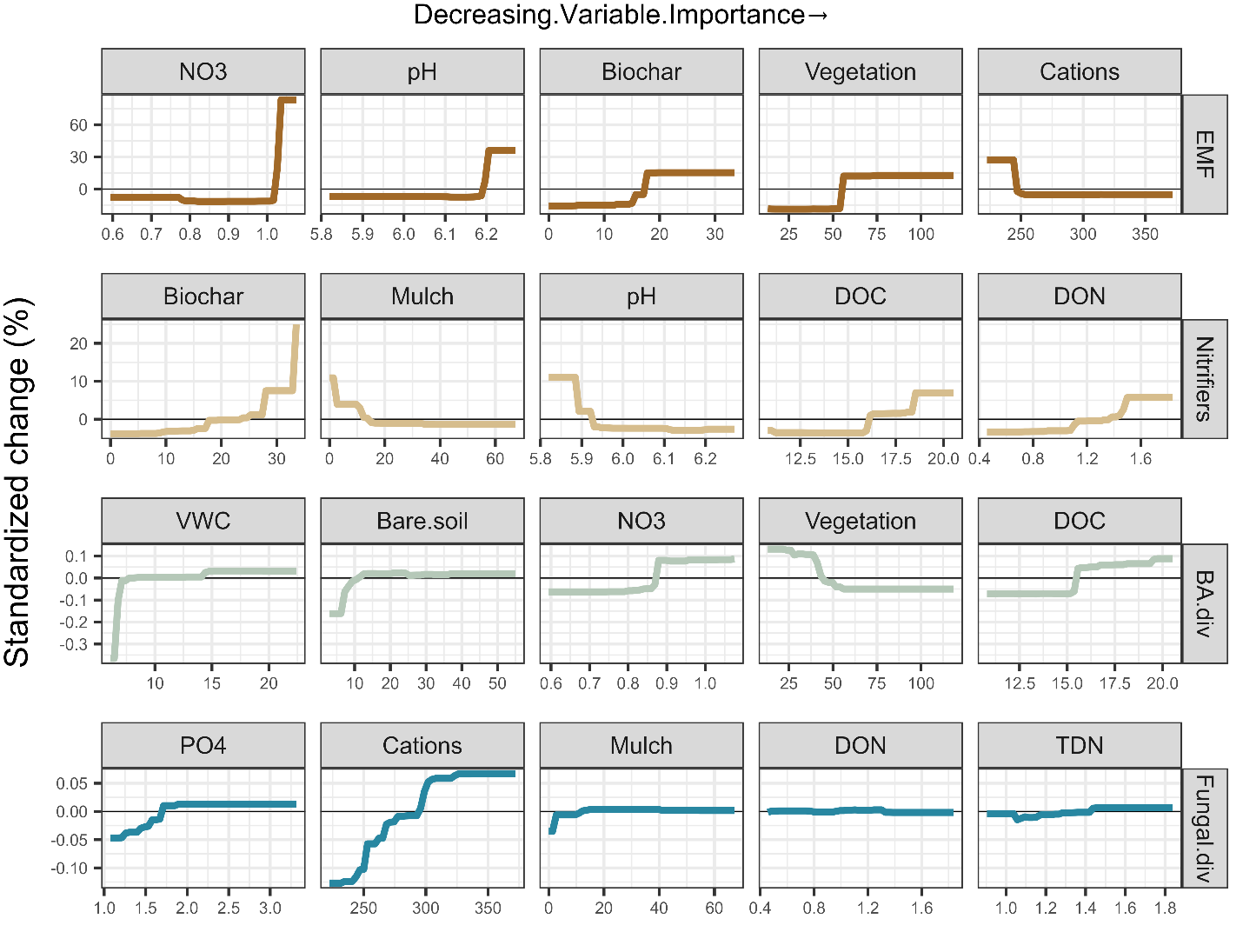
Figure 5: Random forest partial dependence plots show the effect sizes and shapes of responses of microbial functional groups and diversity metrics to the five most important predictors, ordered from left-to-right by decreasing variable importance. For visual clarity among groups, the y-axis shows a standardized percent change from the mean of each functional trait. Acronyms: nitrate (NO3), volumetric water content (VWC), dissolved organic carbon (DOC), total dissolved nitrogen (TDN), total carbon (TotalC), bacterial and archaeal diversity (BA.div), ectomycorrhizal fungi (EMF), phosphate (PO4). Note the greater response of EMF and Nitrifiers to predictors as shown by a larger y-axis scale compared to the two diversity metrics.

3.4. Structural equation models
Structural equation models for O. parryi explained 30% of the variation in LDMC, 36% of the variation in SLA, and 28% of the variation in height (Fig. 6). The full model explained 36% of the variation of SLA, and when aspect was removed it explained 3%. Similarly, when aspect was removed from the LDMC model for O. parryi, variance explained decreased from 30% to 7%. Height was not dominated by a single predictor. The models for V. scoparium (Fig. 7) explained 14% of the variation in LDMC, 13% of the variation in SLA and 19% of the variation in height. Models for V. scoparium were not dominated by a single variable. The main exogenous variables of interest, cover of mulch and biochar, only had direct effects on height in O. parryi, but no other traits or in V. scoparium (Figs. 6,7). Rather, they acted indirectly through mediators, namely cations, VWC, nitrifier relative abundance, phosphates, NH₄⁺, NO₃⁻, fungal diversity and EMF relative abundance. Mulch directly increased VWC, EMF, and decreased cations, NH₄⁺, NO₃⁻, nitrifiers, and fungal diversity. After accounting for those mediators, Mulch had a net positive effect on LDMC of O. parryi, a positive (but not significant) effect on the LDMC of V. scoparium, and a net negative effect on height of O. parryi, and a net negative effect on the SLA of V. scoparium. Biochar had a net positive effect on the LDMC of O. parryi and a net negative effect on the height of V. scoparium.
Our SEM examining the effect of mulch and biochar cover on EMF and nitrifier relative abundances explained 62% of the variation. Relative abundance of EMF had direct positive associations with NO₃⁻, pH, nitrifiers, and mulch cover. It had direct negative associations with PO₄ and bare ground cover. It had a net positive association with biochar cover and a net neutral relationship with mulch cover (Fig. 8).
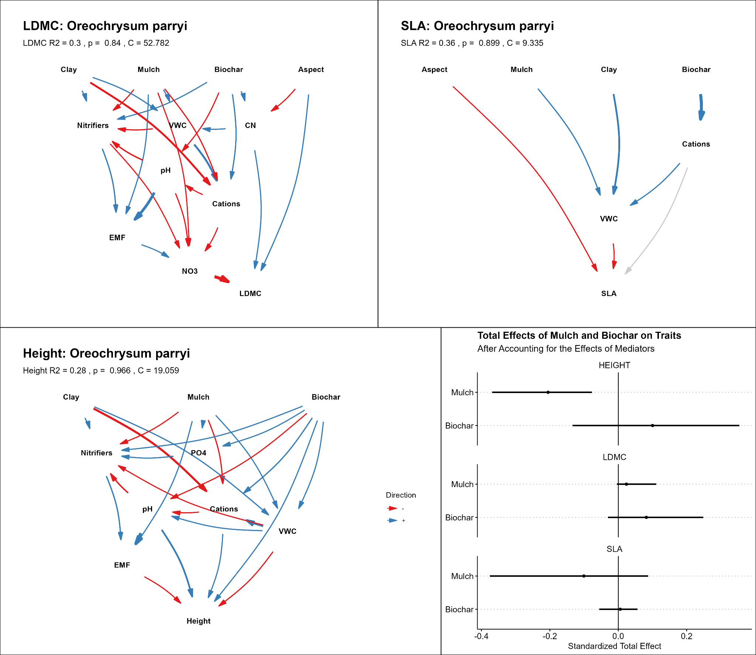
Figure 6: Structural equation model path diagrams for plant functional traits in Oreochrysum parryi. Path standardized effect sizes are denoted by arrow width, whereas path sign (+, -) is denoted by color, with blue arrows indicating a positive relationship, and red arrows a negative relationship. Note that treatment effects manifest through intermediate soil chemical variables, microbial variables, or both, in all cases. All soil variables are at 0-5 cm depths. Abbreviations: total carbon:nitrogen (CN), dissolved inorganic nitrogen (DIN), dissolved organic nitrogen (DON), ammonium (NH4), nitrate (NO3), bacterial and archaeal diversity (BA.div), ectomycorrhizal fungi (EMF), topographic wetness index (TWI), leaf dry matter content (LDMC), and specific leaf area (SLA).

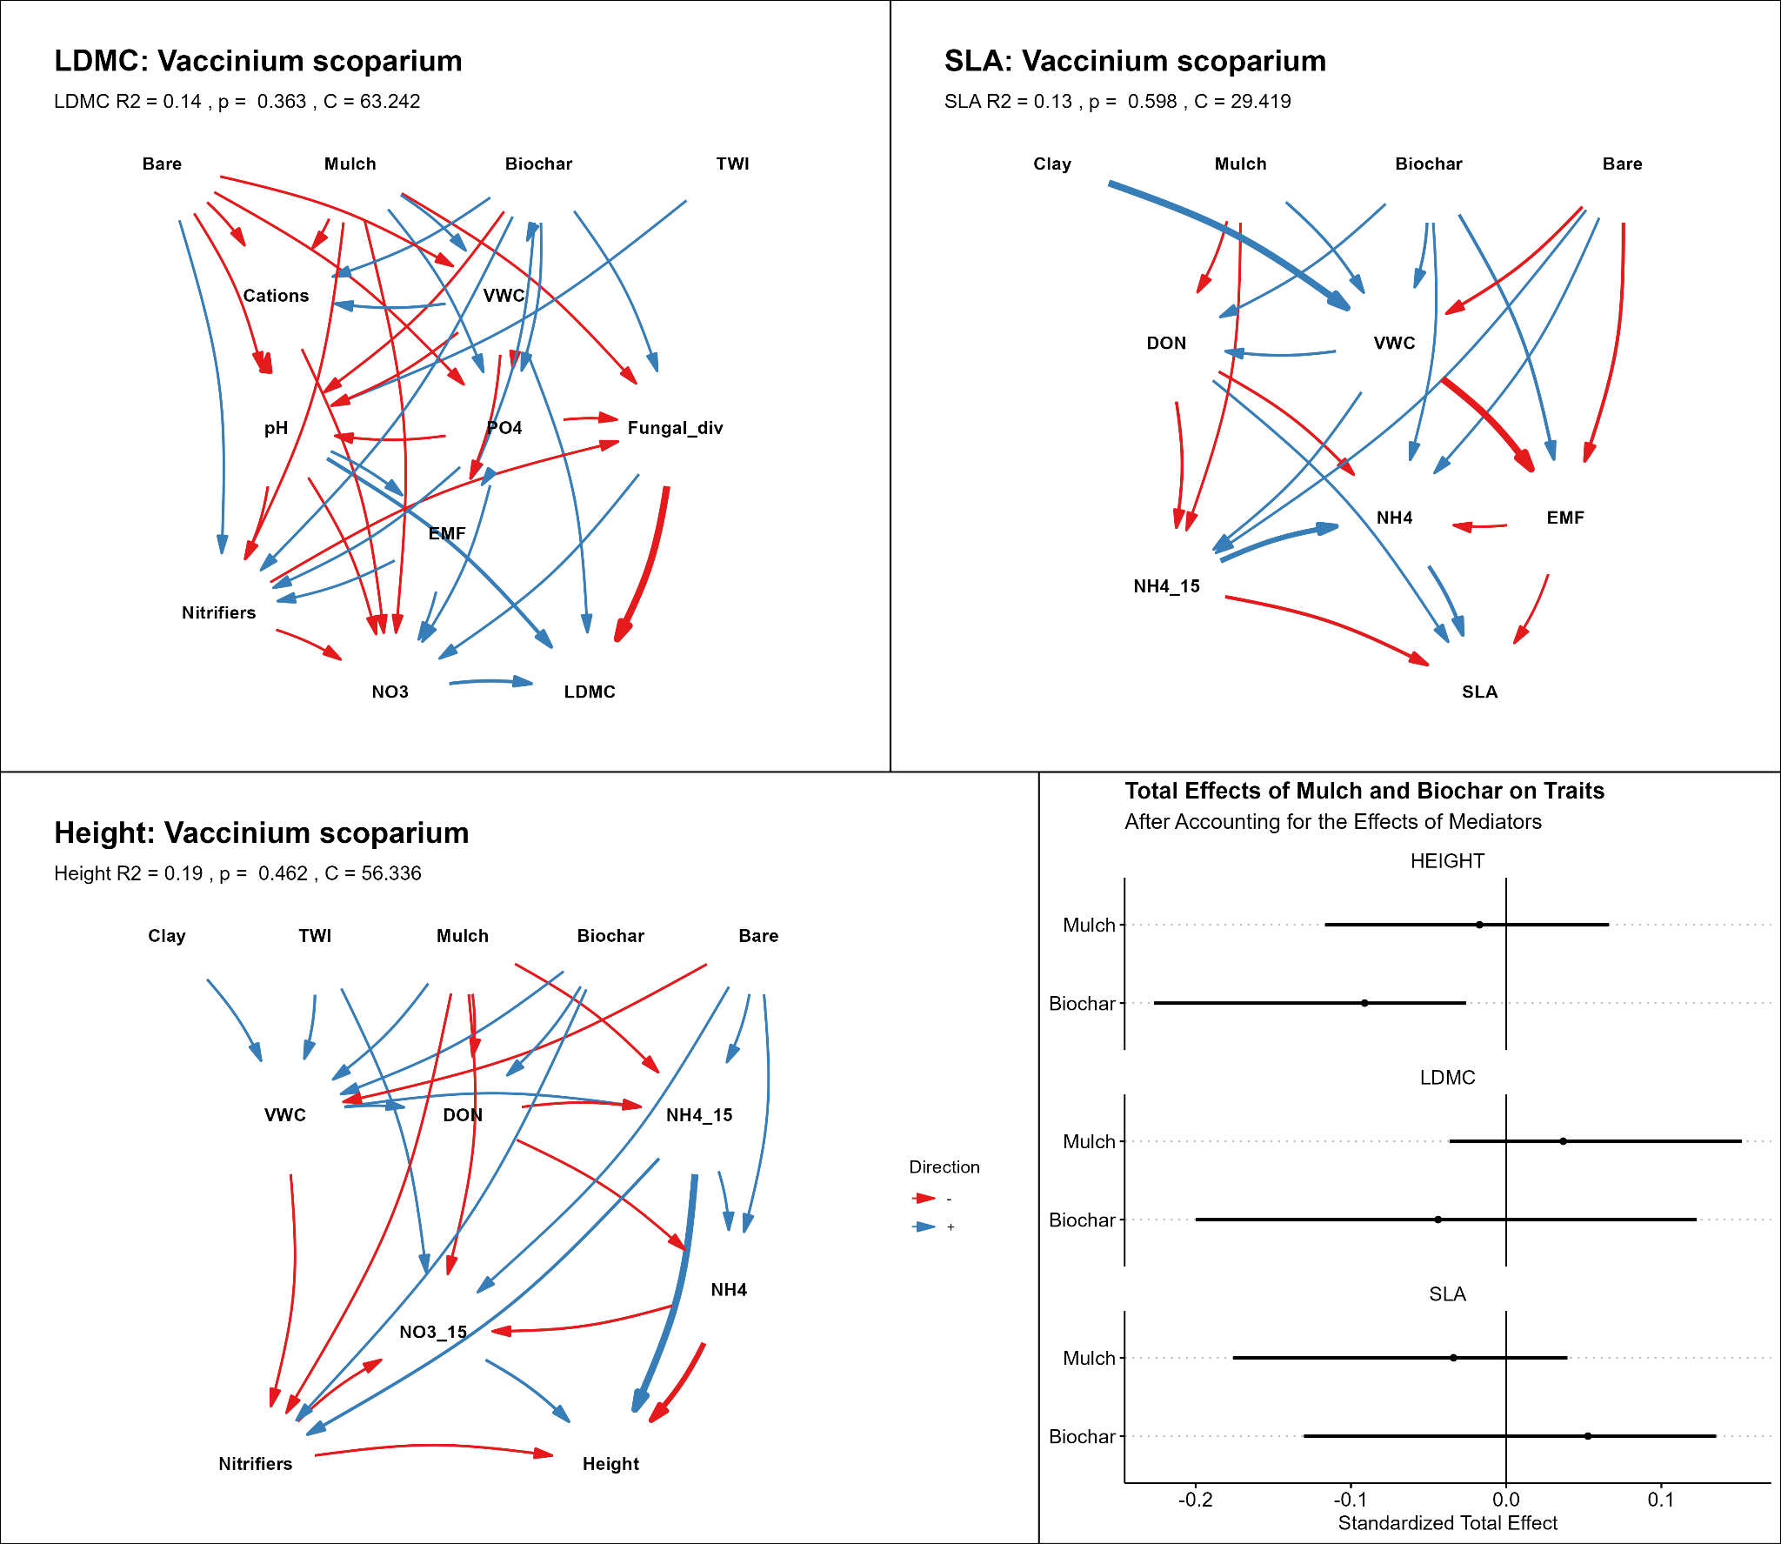
Figure 7: Structural equation model path diagrams for plant functional traits in Vaccinium scoparium. Path standardized effect sizes are denoted by arrow width, whereas path sign (+, -) is denoted by color, with red font indicating a negative relationship and blue font a positive relationship. Note that treatment effects manifest through intermediate soil chemical variables, microbial variables, or both, in all cases. Soil variables ending in 15 are at 5-15 cm depths, all others are at the 0-5 cm depth. Abbreviations: total carbon:nitrogen (CN), dissolved inorganic nitrogen (DIN), dissolved organic nitrogen (DON), ammonium (NH4), nitrate (NO3), bacterial and archaeal diversity (BA.div), ectomycorrhizal fungi (EMF), topographic wetness index (TWI), leaf dry matter content (LDMC), and specific leaf area (SLA).
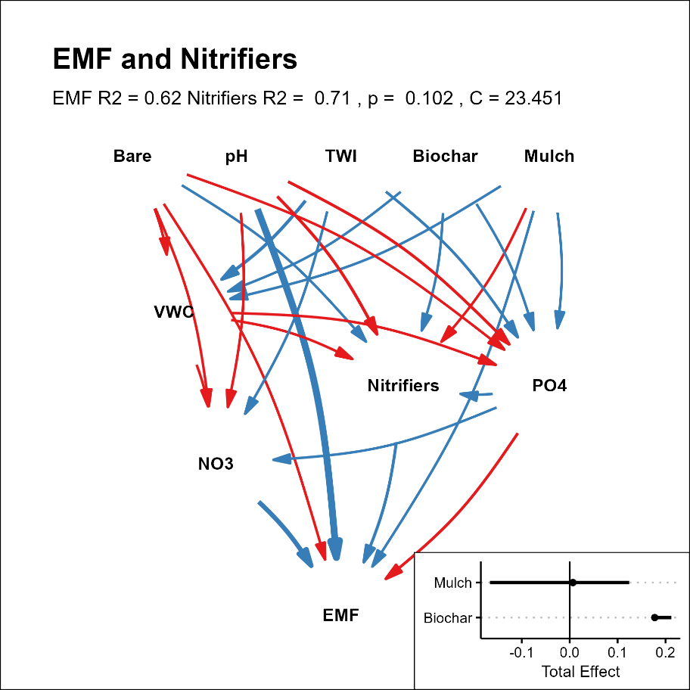
Figure 8: Structural equation model path diagrams for ectomycorrhizal fungi (EMF) and nitrifier relative abundance. Path standardized effect sizes are denoted by arrow width, whereas path sign (+, -) is denoted by color, with red arrows indicating a negative relationship and blue font a positive relationship. Inset shows the total effects of Mulch and Biochar on ectomycorrhizal fungi after accounting for the effects of mediators (Nitrifiers, volumetric water content (VWC), and NO₃⁻). Abbreviations: topographic wetness index (TWI), phosphate (PO4).

4. Discussion

4.1. Post-fire succession and regeneration implications
The results presented here add important context to the understanding of forest recovery dynamics and possible regeneration failures after wildfire. We observed minimal tree recovery thirteen years after fire (Fig. 1b), possibly due to low seed viability following pre-fire bark beetle mortality (Rhoades et al., 2022; Rhoades et al., 2018). Despite limited tree regeneration, our results show the plant community composition changed substantially from 2016 to 2023 (Fig 2a) along expected post-fire succession trajectories. That is, in 2016, the plant community was characterized by a greater abundance of short-lived, early successional species such as fireweed (Chamerion angustifolium), which gave way to a greater cover of perennial species in 2023 including V. scoparium and O. parryi, the two focal species in this study (Fig. S1). Despite clear shifts in community composition and cover from 2016 to 2023, there were no significant differences among soil amendment treatments from the 2023 botanical surveys. This suggests soil amendments had little effect on driving vegetation communities in our study, similar to previous research (Dodson and Peterson, 2010; Fornwalt et al., 2017; Jonas et al., 2019; Santana et al., 2014).
The limited forest regeneration in our study area has led to the emergence of novel vegetation communities, primarily dominated by understory species, which raises questions about long-term dynamics and potential management strategies (Edwards et al., 2015; Roccaforte et al., 2012; Wang and Kemball, 2005). These new communities are not well understood, but it has been shown that understory species can accelerate the recovery of overstory species, suggesting that management actions may be warranted to promote the development and functional resilience of specific communities. For example, V. scoparium, whose cover increases with biochar application (Fig. S1), can promote post-fire seedling regeneration in whitebark pine (Pinus albicaulis) by fostering microbial mutualism (Perkins, 2015). Additionally, V. scoparium cover may be higher pre-fire, and recover better post-fire, in areas that experienced substantial canopy loss due to bark beetles (Carter et al., 2022). Increased resource access due to overstory loss can further promote fruit production, with possible benefits to wildlife (Pengelly and Hamer, 2014). However, other research has shown that higher solar radiation in burn areas without overstory regeneration may not support long-term persistence of V. scoparium (Fornwalt et al., 2024). These impacts could be especially pronounced in areas where bark beetle mortality pre-fire impedes forest recovery (Andrus et al., 2020; Rodman et al., 2022; Stevens-Rumann et al., 2015). Given these contradictory findings, future research should focus on uncertainties to better understand long-term dynamics and improve predictions of western forest resilience to compound disturbances.

4.2. Treatment effects on soil nutrients, chemistry, and microbes
Soil amendment treatments had significant direct effects on soil physical, chemical, and microbial properties, and plant cover in the Church’s Park burn area (Kaiser et al., 2025). Overall, the most pronounced effects of mulch treatments were increases in soil moisture and a reduction in cover of O. parryi (Figs. S1, S3). On the other hand, biochar increased total soil C, DOC, the C:N, and reduced net nitrification. The combined treatments (mulch + biochar) had unique soil and plant responses, enhancing the richness and evenness of soil bacterial and archaeal communities compared to control plots (Fig. 2). This increased microbial diversity is linked to improved nutrient cycling, crucial for plant recovery after fires (Bouskill et al., 2022), and especially shallowly rooted keystone species like V. scoparium. Additionally, the higher soil carbon concentrations from the mulch and biochar treatment likely fostered beneficial microbial activity including increased bacterial diversity and relative abundance of nitrifiers (Fig. 5). These are likely indirect effects for the nitrifiers given their likely autotrophic metabolism. Regardless, soil amendments play an important role in post-fire soil rehabilitation, making them valuable tools for managers dealing with frequent and severe disturbances in forest and shrubland systems (Rhoades et al., 2017; Schuler, 2021).
Sorting microbial species into functional groups or summarizing their diversity provides valuable insights into the direct effects of soil amendment treatments on microbes critical for ecosystem recovery (Figs. 5, 8). In fact, our analyses show that summaries of microbial diversity or relative abundance of key functional groups responded more directly to the treatments than did the microbial community as a whole (Fig. 2b). In particular, biochar was associated with increased nitrifier and EMF relative abundance in both random forest models and SEMs (Figs. 5, 8). These findings supplement previous studies that have documented contradictory effects of biochar on nitrifier abundance and activity (Luo et al., 2016; Rhoades et al., 2017; Yu et al., 2021). In our models, however, biochar did not emerge as an important predictor for fungal or bacterial/archaeal diversity, which is often affected by wildfire (Fox et al., 2022), but mulch was an important predictor for fungal diversity and nitrifier relative abundance. This suggests that the primary impact of soil amendments, especially biochar (Fig. 8), may be on the abundance of specific microbial functional groups rather than on overall community diversity.
We also observed multiple indirect or interactive effects of soil amendment treatments on the microbiome through changes to soil characteristics. Mulch and biochar had contrasting effects on soil pH: increasing with the former and decreasing with the latter (Fig. S3). This can affect the availability of N and P, both of which were important variables in our models predicting microbial relative abundance and diversity (Figs. 5-8). Mulch and biochar can also increase phosphate, which we found to be beneficial to fungal diversity (Fig. 5). This is contrary to the findings of a recent global meta-analysis showing phosphate to decrease fungal diversity (Ma et al., 2023), although positive associations have been reported elsewhere (e.g., Zheng and Song, 2022). Overall, the effects of biochar and mulch applications have important implications for N cycling in forest recovery, particularly through nitrifiers, which may facilitate the supply of inorganic N to EMF and, subsequently, to above-ground biomass. Mulch has the potential to reduce N losses through leaching immediately after fire (Kaiser et al., 2025; Rhoades et al., 2012). Previous research has demonstrated that increased N availability can have a direct, positive effect on mycelial growth if EMF are N-limited (Jörgensen et al., 2024). Furthermore, other studies have shown that EMF can directly use NO₃⁻ as an energy source (France and Reid, 1983; Nygren et al., 2008; Plassard et al., 1994). Because mulch assists in retention of N short term (Rhoades et al., 2012), and biochar in the retention long-term (Kaiser et al., 2025), it is arguable that optimal management approaches would include the combined application of both to best benefit EMF and nitrification processes.
This study further clarifies the importance of EMF in the resilience of lodgepole pine and other western coniferous forests. Ectomycorrhizal fungi are critical symbionts for lodgepole pine (Caiafa et al., 2023) and V. scoparium (Perkins, 2015). Beyond the supply of N, mycorrhizal associations can reduce plant drought stress through direct water transport to plant roots (Kakouridis et al., 2022). These associations may be especially important after fire when decreased surface infiltration can reduce soil moisture (Holden et al., 2015). However, high-severity fire can negatively impact EMF relative abundance and diversity, thereby affecting potential interactions with aboveground biomass (Nelson et al., 2022; Nelson et al., 2024). The soil amendments tested in this study could support greater EMF relative abundances through retention and addition of N and changes to soil pH, which in turn could enhance the mineral nutrition of conifers by promoting greater utilization of organic N (Abuzinadah and Read, 1986; Pelletier et al., 2016). However, mulch, for example, may also inhibit EMF via increases to soil moisture and longer term retention of NO₃⁻ (Fig. 5). Previous work has shown the relative abundance of mycorrhizal fungi to increase in drier soils (de Vries et al., 2018; Lozano et al., 2021), which corresponds with negative relationships between EMF relative abundance and VWC in our random forests and SEMs (Figs. 5-8). Mulch has also been shown to result in 80% lower NO₃⁻ compared to untreated soils after fire (Kaiser et al., 2025), potentially limiting an important energy source for EMF metabolism (France and Reid, 1983; Nygren et al., 2008; Plassard et al., 1994). Future work would benefit from further disentangling soil moisture effects from nutrient changes to improve understanding of these complex interactions on key microbial functional groups.

4.3. Plant functional traits respond indirectly to soil amendments
Plant functional trait responses to soil amendments were complex, interactive, and non-linear, highlighting the importance of our multifaceted analytical approach. Soil amendments had limited direct effects on plant functional traits using analysis of variance (Fig. 3), but we found important indirect and non-linear effects across treatments using random forests and SEMs (Figs. 5-7). In terms of interspecific variability, LDMC was significantly higher in V. scoparium, indicating functional strategies that favor stronger, more robust, leaves with a longer life span than O. parryi. Among treatments, SLA in both species was significantly lower in the mulch plots compared to control plots, suggesting that a variety of treatments on the landscape may promote greater intraspecific variability and thus species resilience as per our expectations. Given the significantly higher VWC in mulch plots, these results were contrary to our initial expectations that treatments with higher VWC would have higher growth rates and SLA. This contradiction might indicate 1) that these species have a drought escape strategy where faster growth is aimed at maximizing nutrient uptake prior to the onset of summer drought (Noy-Meir, 1973; Wolkovich and Cleland, 2014), or 2) that soil nutrients, such as N, are a more limiting resource. Further modeling that includes site characteristics and differences in soil chemistry and microbiome that drive long term soil moisture dynamics provides additional insight, which we describe below.
There was a consistent preference for N form (NH₄⁺ versus NO₃⁻) and microbes (nitrifiers versus EMF), between species in driving plant trait variability (Figs. 4, 6, 7). Moreover, these responses generally displayed shapes that reflect threshold-like responses indicative of saturating responses with increasing fertility (Ågren and Bosatta, 1988; Vitousek, 2004), especially leaf thickness and density (Jager et al., 2015). We found NH₄⁺, DIN, and DON were much stronger predictors of plant trait variability in V. scoparium whereas O. parryi responded more strongly to NO₃⁻. Nitrogen is often the most limiting nutrient for plant growth in temperate ecosystems and can interact with moisture limitations to affect growth (Drobnitch et al., 2024; Vitousek and Howarth, 1991), but uptake and metabolic pathways that lead to preferences for one form or the other are poorly understood at the species-level. In general, NH₄⁺ uptake is less costly in terms of energetics (Salsac et al., 1987) but at ~10% of DIN, NH₄⁺ was far less abundant in this study. NO₃⁻ is typically more abundant but also mobile and prone to leaching after fire, thereby less available for root uptake (Rhea et al., 2022; Rhoades et al., 2019). Our results support a general understanding that ericaceous (acid adapted) shrubs such as V. scoparium prefer NH₄⁺ as they lack the nitrate reductase enzyme to metabolize NO₃⁻. However, studies have shown other Vaccinium species prefer a 2:1 NH₄⁺ to NO₃⁻ ratio (Xu et al., 2021), suggesting a potential role of NO₃⁻ as energy sources for symbionts such as EMF which can convert NO₃⁻ to NH₄⁺ for plant uptake (Nygren et al., 2008). A preference towards both N forms may be also supported by the stronger response of leaf traits in V. scoparium to DIN compared to O. parryi (Fig. 5). These random forest models also show a positive response to increasing NO₃⁻ concentration for plant height, albeit small and V. scoparium responds to pH for LDMC and shows a negative response to NO₃⁻ for SLA and LDMC. This may be due to NO₃⁻ as an energy source for EMF facilitation growth in V. scoparium (France and Reid, 1983). In fact, EMF relative abundance was an important predictor of SLA in V. scoparium, suggesting that EMF increases its growth rate and corroborates documented reports of mutualism between V. scoparium and EMF (Perkins, 2015). Studies have also shown that plant species can display certain plasticity with regards to their N preference (Harrison et al., 2007; Houlton et al., 2007; Wang and Macko, 2011), and thus the interactions between the abundance of different forms of N in the soil and the abundance of N cycling microbes such as nitrifiers and EMF warrants future investigation, especially with regards to post-fire soil amendments in forested ecosystems in the western US.
We also found strong, but inconsistent, effects of soil and topographic predictors on plant trait variability between and within species (Fig. 4). Soil texture, specifically clay content, was an important random forest predictor for SLA in both species, and LDMC in O. parryi. The SEMs indicate this is likely due to decreased cation concentrations and increased VWC in more clayey soils or in areas with higher TWI (Fig. 6). Oreochrysum parryi has been shown to prefer wetter areas (Korb et al., 2007), so it is curious that no traits responded positively to changes in VWC. They did respond positively to TWI and clay percent in the random forest models and positively to increasing northness in the SEMs, however, suggesting that landscape and edaphic factors that drive longer-term soil moisture dynamics may dominate over single time point VWC measurements. Soil pH was also important in the random forests for LDMC in V. scoparium and for height in O. parryi, which may be due to the beneficial impacts of increasing soil pH on leaf N and P concentrations increasing photosynthetic rates as shown in a global synthesis (Maire et al., 2015). Lifecycle and growth strategy differences between the two species may also explain some of the divergent responses. While we found no significant difference in SLA between species (Fig. 3), LDMC was significantly higher in V. scoparium which, combined with the inverse relationship between SLA and LDMC, contradicts previous work showing higher SLA in resprouting species (i.e., V. scoparium) versus reseeding species (i.e., O. parryi) (Anacker et al., 2011). However, it is not certain that O. parryi reestablishes solely via seed after fire (Fornwalt, 2009), but it is clear that V. scoparium reestablishes primarily via resprouting from rhizomatous root systems (Fischer, 1966). We do, however, presume O. parryi regenerates via seed due to their high abundance on the landscape and our observations of seed morphology that is indicative of wind-dispersal. Nonetheless, this greater interspecific variability in traits (specifically LDMC) supports our expectations that recovering ecosystems may favor greater variability in functional traits to increase resilience to biotic and abiotic factors (Henn et al., 2018; Jung et al., 2010).
Despite our multifaceted analytical approach, there remains substantial uncertainty in the drivers of post-fire plant functional trait responses to soil organic amendments. Specific leaf area and LDMC have been shown to respond inversely to nutrient and moisture availability. However, intraspecific variation can often be less than interspecific variation (Siefert et al., 2015), possibly confounding our findings. Uncertainty in our results could also be due to several factors we did not account for in this study. First, we did not consider any root traits, which have been proposed as an additional axis on the plant economics spectrum and are vital to understanding nutrient acquisition (Weigelt et al., 2021). Second, the plant economics spectrum is defined specifically for high-light conditions (Wright et al., 2004), but both O. parryi and V. scoparium are shade adapted species that may produce unexpected patterns of functional strategies when exposed to high-light conditions after fire, such as the novel environment both species must adapt to in this study. Third, our soil samples represent bulk conditions rather than rhizosphere-specific communities that may capture plant-microbe interactions more explicitly. Recently, de Vries (2023) theorized that increased mycorrhizal abundance in the rhizosphere during drought conditions may alter plant traits or physiological processes that attract mutualists or decrease susceptibility to pathogens. Nonetheless, we did observe an expected negative relationship between LDMC and SLA in both species (Fig. 3) and inverse response shapes to soil chemistry (Fig. 4) which supports general understanding of the tradeoff between these traits with regards to resource availability (Blumenthal et al., 2020; Ocheltree et al., 2020).

4.4. Management implications
Ecosystem rehabilitation is an increasingly important aspect of resource management. Especially as shifting climate and increasing disturbances such as wildfire continue to impact ecosystems and drive long-term shifts in ecosystem composition (Coop et al., 2020; Davis et al., 2019; Reilly et al., 2020; Roccaforte et al., 2012). Understanding the impacts of restoration treatments is essential to guiding future land management decisions. However, the results presented here illustrate how treatment effects may not always be directly observable using predefined targets such as vegetation community or plant functional traits. For example, we found little statistical effect of biochar, mulch, or mulch + biochar treatments on plant functional trait variability of community composition (Figs. 2, 3). However, when all components of the system were separated and analyzed using random forests and SEMs, we found important non-linear and indirect effects of amendments through modifications to soil chemistry, nutrients, and microorganisms (Figs. 4-8). The challenge in identifying these responses is an important consideration for resource managers and scientists moving forward to improve effectiveness of rehabilitation treatments and understanding of how systems function following disturbance (Barnard et al., 2019).
Degraded forest ecosystems are increasing globally, underscoring the need for actionable restoration practices to retain important ecosystem services (Hastings et al., 2020; Zirbel et al., 2017). Restoration projects have increasingly emphasized the restoration of ecosystem services and function rather than returning to pre-disturbance conditions (Kollmann et al., 2016; Merchant et al., 2023; Suding, 2011). This study advances understanding by quantifying how plant functional traits respond directly and indirectly to restoration treatments such as soil amendment application (Figs. 4-8). This understanding improves trait-based restoration approaches that link plant traits to ecosystem functions and focus on recovery of ecosystem services in restoration treatment planning (Aubin et al., 2024). Despite a growing use of trait-based approaches, there remains a challenge in operationalizing the process. These challenges arise due to the need for data integration across disciplines and knowledge gaps in how traits respond to restoration efforts (as described in this study), and difficulties with linking traits directly to ecosystem services (Aubin et al., 2016; Merchant et al., 2023). This has limited the use of trait-based approaches and indicates a need for stronger collaboration between researchers and restoration practitioners for effective integration (Gornish et al., 2023). Ultimately, complex and multifaceted goals need to be precisely defined to guide trait selection in restoration treatments (Fiedler et al., 2021).
Our findings emphasize that future studies would benefit from further focus on the impacts of post-fire soil amendments on ecosystem recovery and forest regeneration. Biochar is an increasingly used amendment and is relatively well understood for its impacts to soil fertility and water holding capacity, especially when combined with mulch (Kaiser et al., 2025). Biochar can moderate soil temperature (Zhang et al., 2013), and increase soil P and K, thereby accelerating growth, albeit in a species-specific manner (Gale and Thomas, 2019), and can vary by biochar type, application amount and post-processing (Thomas, 2021). After fire, biochar can increase seedling survival without impacting growth (Marsh et al., 2023). There are several mechanisms by which biochar and other pyrogenic carbon can promote regeneration and affect forest recovery including the improving soil fertility, supporting the growth of fire-adapted species through improved soil fertility and the rapid release of labile nutrients (Gundale et al., 2016; Pluchon et al., 2014). Biochar also includes carbonates of K, Ca, and Mg that can lime the soil, enhancing nutrient availability (Bodí et al., 2014). Mulch supplies C to the soil and can promote N immobilization, with the potential to reduce leaching and mitigate post-fire losses to streams (Homyak et al., 2008; Perry et al., 2010), but more effort is needed to guide careful placement on the landscape, especially when using aerial applications (Rhoades et al., 2025)

4.5. Conclusions
The impact of high-severity fire across the landscape in the Church’s Park burn area remains thirteen years later. Limited tree regeneration and broader shifts in ecosystem states suggest the legacy of fire will be long lasting. In this study, we report an interesting dichotomy wherein organic soil amendments applied post-fire had marginal direct effects on above ground characteristics (vegetation community composition, plant functional traits), despite clear differences in soil chemistry, nutrients, and the microbiome. However, upon closer investigation using random forests and SEMs, our analyses reveal non-linear relationships and complex relationships among soil and microbial properties that drive variation in plant traits and suggest a nuanced but important impact of post-fire restoration treatment on plant resource use strategies. Many indirect and interactive relationships emerged that might appear contrary to expectations if not considered within a broader biotic and abiotic framework. Moreover, the variation of plant functional traits in response to post-fire amendments provides insight into broader understanding of how intraspecific trait variation mediates the effect of environmental changes on plant community composition and function. This study thus provides a first, to our knowledge, perspective on how management actions may provide an initial foundation for the development of ecosystem structure and function through a trait-based approach aimed at developing a plant community comprised of species with variable resilience against climate stressors to improve forest regeneration.

Open research statement
Data and code will be publicly available on GitHub at https://www.github.com/admahood/church_park upon publication and given a digital object identifier via Zenodo.

Acknowledgements
Research was supported by the USDA Agricultural Research Service and the US Forest Service Rocky Mountain Research Station. This project was also partially supported by Joint Fire Science Program #23-2-01-10 (jdbld 4414) and Bipartisan Infrastructure Law funding We are grateful to Kerry Minatre and Roger Tyler for establishing the initial research plots and to Shanthini Ode and Giovanni Borsari for assistance with field and lab data collection. USDA is an equal opportunity employer and provider.

Declaration of generative AI and AI-assisted technologies in the writing process
During the preparation of this work the authors used ChatGPT in order to improve readability and flow of the text. After using this tool/service, the authors reviewed and edited the content as needed and take full responsibility for the content of the publication.

References
Abatzoglou, J.T. and Williams, A.P., 2016. Impact of anthropogenic climate change on wildfire across western US forests. Proceedings of the National Academy of Sciences, 113(42): 11770-11775.
Abuzinadah, R. and Read, D., 1986. The role of proteins in the nitrogen nutrition of ectomycorrhizal plants: III. Protein utilization by Betula, Picea and Pinus in mycorrhizal association with Hebeloma crustuliniforme. New Phytologist, 103(3): 507-514.
Ågren, G.I. and Bosatta, E., 1988. Nitrogen saturation of terrestrial ecosystems. Environmental Pollution, 54(3-4): 185-197.
Alstatt, D. and Miles, R.L., 1983. Soil Survey of Grand County Area, Colorado.
Anacker, B. et al., 2011. Ecological strategies in California chaparral: interacting effects of soils, climate, and fire on specific leaf area. Plant Ecology & Diversity, 4(2-3): 179-188.
Anderson, M.J. and Santana‐Garcon, J., 2015. Measures of precision for dissimilarity‐based multivariate analysis of ecological communities. Ecology letters, 18(1): 66-73.
Andrus, R.A., Hart, S.J. and Veblen, T.T., 2020. Forest recovery following synchronous outbreaks of spruce and western balsam bark beetle is slowed by ungulate browsing. Ecology, 101(5): e02998.
Apprill, A., McNally, S., Parsons, R. and Weber, L., 2015. Minor revision to V4 region SSU rRNA 806R gene primer greatly increases detection of SAR11 bacterioplankton. Aquatic Microbial Ecology, 75(2): 129-137.
Aubin, I. et al., 2024. Restoring forest ecosystem services through trait-based ecology. Environmental Reviews, 32(4): 498-524.
Aubin, I. et al., 2016. Traits to stay, traits to move: a review of functional traits to assess sensitivity and adaptive capacity of temperate and boreal trees to climate change. Environmental Reviews, 24(2): 164-186.
Barnard, D. et al., 2023. Wildfire and climate change amplify knowledge gaps linking mountain source-water systems and agricultural water supply in the western United States. Agricultural Water Management, 286.
Barnard, D.M. et al., 2019. Cannot see the random forest for the decision trees: selecting predictive models for restoration ecology. Restoration Ecology, 27(5): 1053-1063.
Bautista, S., Robichaud, P.R. and Bladé, C., 2009. Post-fire mulching, Fire effects on soils and restoration strategies. CRC press, pp. 369-388.
Beven, K.J. and Kirkby, M.J., 1979. A physically based, variable contributing area model of basin hydrology/Un modèle à base physique de zone d'appel variable de l'hydrologie du bassin versant. Hydrological sciences journal, 24(1): 43-69.
Blumenthal, D.M. et al., 2020. Traits link drought resistance with herbivore defence and plant economics in semi‐arid grasslands: The central roles of phenology and leaf dry matter content. Journal of Ecology, 108(6): 2336-2351.
Bodí, M.B. et al., 2014. Wildland fire ash: production, composition and eco-hydro-geomorphic effects. Earth-Science Reviews, 130: 103-127.
Bontrager, J.D., Morgan, P., Hudak, A.T. and Robichaud, P.R., 2019. Long-term vegetation response following post-fire straw mulching. Fire Ecology, 15: 1-12.
Bormann, B.T., Homann, P.S., Darbyshire, R.L. and Morrissette, B.A., 2008. Intense forest wildfire sharply reduces mineral soil C and N: the first direct evidence. Canadian Journal of Forest Research, 38(11): 2771-2783.
Bouskill, N.J., Mekonnen, Z., Zhu, Q., Grant, R. and Riley, W.J., 2022. Microbial contribution to post-fire tundra ecosystem recovery over the 21st century. Communications Earth & Environment, 3(1): 26.
Breiman, L., 2001. Random forests. Machine learning, 45: 5-32.
Breiman, L., Cutler, A., Liaw, A. and Wiener, M., 2018. Package ‘randomforest’. University of California, Berkeley: Berkeley, CA, USA.
Brudvig, L.A. and Mabry, C.M., 2008. Trait‐based filtering of the regional species pool to guide understory plant reintroductions in Midwestern oak savannas, USA. Restoration Ecology, 16(2): 290-304.
Caiafa, M.V. et al., 2023. Distinct fungal and bacterial responses to fire severity and soil depth across a ten-year wildfire chronosequence in beetle-killed lodgepole pine forests. Forest Ecology and Management, 544: 121160.
Carmona-Yáñez, M.D. et al., 2023. Short-term impacts of wildfire and post-fire mulching on ecosystem multifunctionality in a semi-arid pine forest. Forest Ecology and Management, 541: 121000.
Carter, T.A., Fornwalt, P.J., Dwire, K.A. and Laughlin, D.C., 2022. Understory plant community responses to widespread spruce mortality in a subalpine forest. Journal of Vegetation Science, 33(1): e13109.
Certini, G., 2005. Effects of fire on properties of forest soils: a review. Oecologia, 143: 1-10.
Chapman, T.B., Veblen, T.T. and Schoennagel, T., 2012. Spatiotemporal patterns of mountain pine beetle activity in the southern Rocky Mountains. Ecology, 93(10): 2175-2185.
Coop, J.D. et al., 2020. Wildfire-driven forest conversion in western North American landscapes. BioScience, 70(8): 659-673.
Davis, K.T. et al., 2019. Wildfires and climate change push low-elevation forests across a critical climate threshold for tree regeneration. Proceedings of the National Academy of Sciences, 116(13): 6193-6198.
de Vries, F., Lau, J., Hawkes, C. and Semchenko, M., 2023. Plant–soil feedback under drought: does history shape the future? Trends in Ecology & Evolution, 38(8): 708-718.
de Vries, F.T. et al., 2018. Soil bacterial networks are less stable under drought than fungal networks. Nature communications, 9(1): 3033.
Dixon, P., 2003. VEGAN, a package of R functions for community ecology. Journal of vegetation science, 14(6): 927-930.
Dodson, E.K. and Peterson, D.W., 2010. Mulching effects on vegetation recovery following high severity wildfire in north-central Washington State, USA. Forest Ecology and Management, 260(10): 1816-1823.
Dove, N.C., Safford, H.D., Bohlman, G.N., Estes, B.L. and Hart, S.C., 2020. High‐severity wildfire leads to multi‐decadal impacts on soil biogeochemistry in mixed‐conifer forests. Ecological Applications, 30(4): e02072.
Drobnitch, S. et al., 2024. Can nitrogen availability impact plant performance under water stress? A review of traits, mechanisms, and whole plant effects. Plant and Soil: 1-23.
Ebel, B.A., 2012. Wildfire impacts on soil‐water retention in the Colorado Front Range, United States. Water Resources Research, 48(12).
Edwards, M., Krawchuk, M.A. and Burton, P.J., 2015. Short-interval disturbance in lodgepole pine forests, British Columbia, Canada: Understory and overstory response to mountain pine beetle and fire. Forest Ecology and Management, 338: 163-175.
Fiedler, S. et al., 2021. Global change shifts trade‐offs among ecosystem functions in woodlands restored for multifunctionality. Journal of Applied Ecology, 58(8): 1705-1717.
Fischer, W.C., 1966. Fire effects information system: user's guide, 327. US Department of Agriculture, Forest Service, Intermountain Research Station.
Fornwalt, P. et al., 2024. Chapter 5: Vulnerability of Major Colorado Front Range Tree Species to Climate Change. In: B. Hanberry (Editor), Colorado Front Range Climate Change Vulnerability Assessment for National Forests. General Technical Report RMRS-GTR-438. US Department of Agriculture, Forest Service, Rocky Mountain Research Station, Fort Collins, CO.
Fornwalt, P.J., 2009. Disturbance impacts on understory plant communities of the Colorado Front Range. Colorado State University.
Fornwalt, P.J., Rocca, M.E., Battaglia, M.A., Rhoades, C.C. and Ryan, M.G., 2017. Mulching fuels treatments promote understory plant communities in three Colorado, USA, coniferous forest types. Forest Ecology and Management, 385: 214-224.
Fox, S. et al., 2022. Fire as a driver of fungal diversity—A synthesis of current knowledge. Mycologia, 114(2): 215-241.
France, R.C. and Reid, C., 1983. Interactions of nitrogen and carbon in the physiology of ectomycorrhizae. Canadian Journal of Botany, 61(3): 964-984.
Gale, N.V. and Thomas, S.C., 2019. Dose-dependence of growth and ecophysiological responses of plants to biochar. Science of the Total Environment, 658: 1344-1354.
Gee, G., 1986. Particle size analysis. Methods of soil analysis/ASA and SSSA.
Gleason, S.M. et al., 2018. Shoot growth of woody trees and shrubs is predicted by maximum plant height and associated traits. Functional Ecology, 32(2): 247-259.
Gornish, E.S. et al., 2023. Functional traits are used in restoration practice: a response to Merchant et al.(2022). Restoration Ecology, 31(7): e13880.
Gundale, M.J., Nilsson, M.C., Pluchon, N. and Wardle, D.A., 2016. The effect of biochar management on soil and plant community properties in a boreal forest. GCB Bioenergy, 8(4): 777-789.
Harrison, K.A., Bol, R. and Bardgett, R.D., 2007. Preferences for different nitrogen forms by coexisting plant species and soil microbes. Ecology, 88(4): 989-999.
Harvey, B.J., Donato, D.C. and Turner, M.G., 2016. Drivers and trends in landscape patterns of stand-replacing fire in forests of the US Northern Rocky Mountains (1984–2010). Landscape Ecology, 31: 2367-2383.
Hastings, Z. et al., 2020. Integrating co‐production and functional trait approaches for inclusive and scalable restoration solutions. Conservation Science and Practice, 2(9): e250.
Henn, J.J. et al., 2018. Intraspecific trait variation and phenotypic plasticity mediate alpine plant species response to climate change. Frontiers in Plant Science, 9: 1548.
Hijmans, R.J. et al., 2022. Package ‘terra’. Maintainer: Vienna, Austria.
Holden, S.R., Berhe, A.A. and Treseder, K.K., 2015. Decreases in soil moisture and organic matter quality suppress microbial decomposition following a boreal forest fire. Soil Biology and Biochemistry, 87: 1-9.
Homann, P.S., Bormann, B.T., Darbyshire, R.L. and Morrissette, B.A., 2011. Forest soil carbon and nitrogen losses associated with wildfire and prescribed fire. Soil Science Society of America Journal, 75(5): 1926-1934.
Homyak, P.M., Yanai, R.D., Burns, D.A., Briggs, R.D. and Germain, R.H., 2008. Nitrogen immobilization by wood-chip application: protecting water quality in a northern hardwood forest. Forest Ecology and Management, 255(7): 2589-2601.
Houlton, B.Z., Sigman, D.M., Schuur, E.A. and Hedin, L.O., 2007. A climate-driven switch in plant nitrogen acquisition within tropical forest communities. Proceedings of the National Academy of Sciences, 104(21): 8902-8906.
Huckaby, L.S. and Moir, W., 1998. Forest communities at fraser experimental forest, Colorado. The Southwestern Naturalist: 204-218.
Jacobucci, R., 2017. regsem: Regularized structural equation modeling. arXiv preprint arXiv:1703.08489.
Jager, M.M., Richardson, S.J., Bellingham, P.J., Clearwater, M.J. and Laughlin, D.C., 2015. Soil fertility induces coordinated responses of multiple independent functional traits. Journal of Ecology, 103(2): 374-385.
Jonas, J.L., Berryman, E., Wolk, B., Morgan, P. and Robichaud, P.R., 2019. Post-fire wood mulch for reducing erosion potential increases tree seedlings with few impacts on understory plants and soil nitrogen. Forest Ecology and Management, 453: 117567.
Jörgensen, K., Clemmensen, K.E., Wallander, H. and Lindahl, B.D., 2024. Ectomycorrhizal fungi are more sensitive to high soil nitrogen levels in forests exposed to nitrogen deposition. New Phytologist, 242(4): 1725-1738.
Jung, V., Violle, C., Mondy, C., Hoffmann, L. and Muller, S., 2010. Intraspecific variability and trait‐based community assembly. Journal of ecology, 98(5): 1134-1140.
Kaiser, S. et al., 2025. Long-term soil nutrient and understory plant responses to post-fire rehabilitation in a lodgepole pine forest. Forest Ecology and Management, 575: 122359.
Kakouridis, A. et al., 2022. Routes to roots: direct evidence of water transport by arbuscular mycorrhizal fungi to host plants. New Phytologist, 236(1): 210-221.
Kampf, S.K. et al., 2022. Increasing wildfire impacts on snowpack in the western US. Proceedings of the National Academy of Sciences, 119(39): e2200333119.
Kassambara, A., 2018. ggpubr:'ggplot2'based publication ready plots. R package version: 2.
Kollmann, J. et al., 2016. Integrating ecosystem functions into restoration ecology—recent advances and future directions. Restoration Ecology, 24(6): 722-730.
Korb, J.E., Daniels, M.L., Laughlin, D.C. and Fulé, P.Z., 2007. Understory communities of warm-dry, mixed-conifer forests in southwestern Colorado. The Southwestern Naturalist, 52(4): 493-503.
Lozano, Y.M., Aguilar-Trigueros, C.A., Roy, J. and Rillig, M.C., 2021. Drought induces shifts in soil fungal communities that can be linked to root traits across 24 plant species. New Phytologist, 232: 1917-1929.
Luo, Y., Yu, Z., Zhang, K., Xu, J. and Brookes, P.C., 2016. The properties and functions of biochars in forest ecosystems. Journal of Soils and Sediments, 16: 2005-2020.
Ma, X. et al., 2023. Global arbuscular mycorrhizal fungal diversity and abundance decreases with soil available phosphorus. Global Ecology and Biogeography, 32(8): 1423-1434.
Mahood, A.L., 2024. topomicro: Topography and Microclimate Tools R package version 0.4.1, https://www.github.com/admahood/topomicro.
Maire, V. et al., 2015. Global effects of soil and climate on leaf photosynthetic traits and rates. Global Ecology and Biogeography, 24(6): 706-717.
Mallick, H. et al., 2021. Multivariable association discovery in population-scale meta-omics studies. PLoS computational biology, 17(11): e1009442.
Marsh, C., Blankinship, J.C. and Hurteau, M.D., 2023. Effects of nurse shrubs and biochar on planted conifer seedling survival and growth in a high-severity burn patch in New Mexico, USA. Forest Ecology and Management, 537: 120971.
McCune, B. and Keon, D., 2002. Equations for potential annual direct incident radiation and heat load. Journal of vegetation science, 13(4): 603-606.
McGill, B.J., Enquist, B.J., Weiher, E. and Westoby, M., 2006. Rebuilding community ecology from functional traits. Trends in ecology & evolution, 21(4): 178-185.
Merchant, T.K., Henn, J.J., de Silva, I., Van Cleemput, E. and Suding, K.N., 2023. Four reasons why functional traits are not being used in restoration practice. Restoration Ecology, 31(3): e13788.
Minchin, P.R., 1987. An evaluation of the relative robustness of techniques for ecological ordination, Theory and models in vegetation science: Proceedings of Symposium, Uppsala, July 8–13, 1985. Springer, pp. 89-107.
Nelson, A.R. et al., 2022. Wildfire-dependent changes in soil microbiome diversity and function. Nature microbiology: 1-12.
Nelson, A.R. et al., 2024. Wildfire impact on soil microbiome life history traits and roles in ecosystem carbon cycling. ISME Communications, 4(1): ycae108.
Nguyen, N.H. et al., 2016. FUNGuild: an open annotation tool for parsing fungal community datasets by ecological guild. Fungal ecology, 20: 241-248.
Niklas, K.J., Shi, P., Gielis, J., Schrader, J. and Niinemets, Ü., 2023. Leaf functional traits: Ecological and evolutionary implications. Frontiers Media SA, pp. 1169558.
Nilsson, R.H. et al., 2019. The UNITE database for molecular identification of fungi: handling dark taxa and parallel taxonomic classifications. Nucleic acids research, 47(D1): D259-D264.
Noy-Meir, I., 1973. Desert ecosystems: environment and producers. Annual review of ecology and systematics, 4(1): 25-51.
NRCS, U., 2013. Snowpack telemetry (SnoTel) precipitation data sites 335, 970, 1186, 1187, 9175. In: N.R.C.S. US Department of Agriculture (Editor).
Nygren, C.M. et al., 2008. Growth on nitrate and occurrence of nitrate reductase‐encoding genes in a phylogenetically diverse range of ectomycorrhizal fungi. New Phytologist, 180(4): 875-889.
Ocheltree, T. et al., 2020. Identification of suites of traits that explains drought resistance and phenological patterns of plants in a semi-arid grassland community. Oecologia, 192(1): 55-66.
Oksanen, J. et al., 2007. The vegan package. Community ecology package, 10(631-637): 719.
Ortega, R. et al., 2022. The Impacts of Post-Fire Straw Mulching and Salvage Logging on Soil Properties and Plant Diversity in a Mediterranean Burned Pine Forest. Forests, 13(10): 1580.
Parada, A.E., Needham, D.M. and Fuhrman, J.A., 2016. Every base matters: assessing small subunit rRNA primers for marine microbiomes with mock communities, time series and global field samples. Environmental microbiology, 18(5): 1403-1414.
Pelletier, J.D. et al., 2016. A gridded global data set of soil, intact regolith, and sedimentary deposit thicknesses for regional and global land surface modeling. Journal of Advances in Modeling Earth Systems, 8(1): 41-65.
Pengelly, I. and Hamer, D., 2014. Grouseberry (Vaccinium scoparium Leiberg ex Coville) fruit production in forest openings in Banff National Park, Alberta. The Canadian Field-Naturalist, 128(4): 400-407.
Perez-Harguindeguy, N. et al., 2016. Corrigendum to: New handbook for standardised measurement of plant functional traits worldwide. Australian Journal of botany, 64(8): 715-716.
Perkins, J.L., 2015. Facilitation of Pinus albicaulis seedling regeneration by Vaccinium scoparium. Forest Ecology and Management, 349: 55-65.
Perry, L.G., Blumenthal, D.M., Monaco, T.A., Paschke, M.W. and Redente, E.F., 2010. Immobilizing nitrogen to control plant invasion. Oecologia, 163: 13-24.
Plassard, C., Barry, D., Eltrop, L. and Mousain, D., 1994. Nitrate uptake in maritime pine (Pinus pinaster) and the ectomycorrhizal fungus Hebeloma cylindrosporum: effect of ectomycorrhizal symbiosis. Canadian Journal of Botany, 72(2): 189-197.
Pluchon, N., Gundale, M.J., Nilsson, M.C., Kardol, P. and Wardle, D.A., 2014. Stimulation of boreal tree seedling growth by wood‐derived charcoal: effects of charcoal properties, seedling species and soil fertility. Functional Ecology, 28(3): 766-775.
Prats, S.A., Wagenbrenner, J.W., Martins, M.A., Malvar, M.C. and Keizer, J.J., 2016. Hydrologic implications of post‐fire mulching across different spatial scales. Land Degradation & Development, 27(5): 1440-1452.
Pressler, Y., Moore, J.C. and Cotrufo, M.F., 2019. Belowground community responses to fire: meta‐analysis reveals contrasting responses of soil microorganisms and mesofauna. Oikos, 128(3): 309-327.
Quast, C. et al., 2012. The SILVA ribosomal RNA gene database project: improved data processing and web-based tools. Nucleic acids research, 41(D1): D590-D596.
Rabus, B., Eineder, M., Roth, A. and Bamler, R., 2003. The shuttle radar topography mission—a new class of digital elevation models acquired by spaceborne radar. ISPRS journal of photogrammetry and remote sensing, 57(4): 241-262.
Reich, P.B., 2014. The world‐wide ‘fast–slow’plant economics spectrum: a traits manifesto. Journal of ecology, 102(2): 275-301.
Reilly, M.J. et al., 2020. Repeated, high-severity wildfire catalyzes invasion of non-native plant species in forests of the Klamath Mountains, northern California, USA. Biological Invasions, 22: 1821-1828.
Rhea, A.E., Covino, T.P., Rhoades, C.C. and Brooks, A.C., 2022. Use of geostatistical models to evaluate landscape and stream network controls on post‐fire stream nitrate concentrations. Hydrological Processes, 36(9): e14689.
Rhoades, C., Battaglia, M., Rocca, M. and Ryan, M., 2012. Short-and medium-term effects of fuel reduction mulch treatments on soil nitrogen availability in Colorado conifer forests. Forest Ecology and Management, 276: 231-238.
Rhoades, C.C. et al., 2019. The legacy of a severe wildfire on stream nitrogen and carbon in headwater catchments. Ecosystems, 22(3): 643-657.
Rhoades, C.C., Fegel, T.S., Hubbard, R.M. and Chambers, M.E., 2022. Limited seed viability in long-dead serotinous lodgepole pine trees in the Southern Rockies, USA. Forest Ecology and Management, 526: 120565.
Rhoades, C.C. et al., 2017. Examining the Potential of Forest Residue‐Based Amendments for Post‐Wildfire Rehabilitation in Colorado, USA. Scientifica, 2017(1): 4758316.
Rhoades, C.C., Pelz, K.A., Fornwalt, P.J., Wolk, B.H. and Cheng, A.S., 2018. Overlapping bark beetle outbreaks, salvage logging and wildfire restructure a lodgepole pine ecosystem. Forests, 9(3): 101.
Rhoades, C.C., Richardson, M.J., Fegel, T.S. and Kampf, S.K., 2025. Assessing the effects of woody mulch on post-fire soil and stream nitrogen at experimental and operational scales. Forest Ecology and Management, 578: 122490.
Robeson, M.S. et al., 2021. RESCRIPt: Reproducible sequence taxonomy reference database management. PLoS computational biology, 17(11): e1009581.
Robichaud, P., Jennewein, J., Sharratt, B., Lewis, S. and Brown, R., 2017. Evaluating the effectiveness of agricultural mulches for reducing post-wildfire wind erosion. Aeolian research, 27: 13-21.
Roccaforte, J.P., Fulé, P.Z., Chancellor, W.W. and Laughlin, D.C., 2012. Woody debris and tree regeneration dynamics following severe wildfires in Arizona ponderosa pine forests. Canadian Journal of Forest Research, 42(3): 593-604.
Rodman, K.C. et al., 2022. Rocky Mountain forests are poised to recover following bark beetle outbreaks but with altered composition. Journal of Ecology, 110(12): 2929-2949.
Rother, M.T., Veblen, T.T. and Furman, L.G., 2015. A field experiment informs expected patterns of conifer regeneration after disturbance under changing climate conditions. Canadian Journal of Forest Research, 45(11): 1607-1616.
Salsac, L., Chaillou, S.S., Morot-Gaudry, J., Lesaint, C. and Jolivet, E., 1987. Nitrate and ammonium nutrition in plants. Plant physiology and biochemistry, 25(6): 805-812.
Santana, V.M., Alday, J.G. and Baeza, M.J., 2014. Mulch application as post-fire rehabilitation treatment does not affect vegetation recovery in ecosystems dominated by obligate seeders. Ecological engineering, 71: 80-86.
Santín, C., Doerr, S.H., Otero, X.L. and Chafer, C.J., 2015. Quantity, composition and water contamination potential of ash produced under different wildfire severities. Environmental Research, 142: 297-308.
Schneider, C.A., Rasband, W.S. and Eliceiri, K.W., 2012. NIH Image to ImageJ: 25 years of image analysis. Nature methods, 9(7): 671-675.
Schuler, S.M., 2021. Fire Effects on Soil Properties: Amending Post-Fire Soils with Native Microbial Communities and Biochar to Improve Sagebrush Performance. Boise State University.
Siefert, A., Lesser, M.R. and Fridley, J.D., 2015. How do climate and dispersal traits limit ranges of tree species along latitudinal and elevational gradients? Global Ecology and Biogeography, 24(5): 581-593.
Stanke, H., Finley, A.O., Domke, G.M., Weed, A.S. and MacFarlane, D.W., 2021. Over half of western United States' most abundant tree species in decline. Nature Communications, 12(1): 451.
Stevens-Rumann, C., Morgan, P. and Hoffman, C., 2015. Bark beetles and wildfires: How does forest recovery change with repeated disturbances in mixed conifer forests? Ecosphere, 6(6): 1-17.
Stevens-Rumann, C.S. and Morgan, P., 2019. Tree regeneration following wildfires in the western US: a review. Fire Ecology, 15(1): 1-17.
Suding, K.N., 2011. Toward an era of restoration in ecology: successes, failures, and opportunities ahead. Annual review of ecology, evolution, and systematics, 42(1): 465-487.
Team, R.C., 2021. A language and environment for statistical computing. (No Title).
Thomas, S.C., 2021. Post-processing of biochars to enhance plant growth responses: a review and meta-analysis. Biochar, 3(4): 437-455.
USFS, 2010. Church's Park Fire - Burned Area Emergency Rehabilitation Burn Severity Estimate - Technical Report.
Vitousek, P.M., 2004. Nutrient cycling and limitation: Hawai'i as a model system. Princeton University Press.
Vitousek, P.M. and Howarth, R.W., 1991. Nitrogen limitation on land and in the sea: how can it occur? Biogeochemistry, 13: 87-115.
Wan, S., Hui, D. and Luo, Y., 2001. Fire effects on nitrogen pools and dynamics in terrestrial ecosystems: a meta‐analysis. Ecological Applications, 11(5): 1349-1365.
Wang, G.G. and Kemball, K.J., 2005. Effects of fire severity on early development of understory vegetation. Canadian Journal of Forest Research, 35(2): 254-262.
Wang, L. and Macko, S.A., 2011. Constrained preferences in nitrogen uptake across plant species and environments. Plant, Cell & Environment, 34(3): 525-534.
Weigelt, A. et al., 2021. An integrated framework of plant form and function: the belowground perspective. New Phytologist, 232(1): 42-59.
Westoby, M. and Wright, I.J., 2006. Land-plant ecology on the basis of functional traits. Trends in ecology & evolution, 21(5): 261-268.
White, T.J., Bruns, T., Lee, S. and Taylor, J., 1990. Amplification and direct sequencing of fungal ribosomal RNA genes for phylogenetics. PCR protocols: a guide to methods and applications, 18(1): 315-322.
Wolkovich, E.M. and Cleland, E.E., 2014. Phenological niches and the future of invaded ecosystems with climate change. AoB plants, 6: plu013.
Wright, A. and Francia, R., 2024. Plant traits, microclimate temperature and humidity: A research agenda for advancing nature‐based solutions to a warming and drying climate. Journal of Ecology.
Wright, I.J. et al., 2004. The worldwide leaf economics spectrum. nature, 428(6985): 821-827.
Xu, J. et al., 2021. Preferential ammonium: nitrate ratio of blueberry is regulated by nitrogen transport and reduction systems. Scientia Horticulturae, 288: 110345.
Yu, M. et al., 2021. Plant material and its biochar differ in their effects on nitrogen mineralization and nitrification in a subtropical forest soil. Science of the Total Environment, 763: 143048.
Zhang, Q. et al., 2013. Effects of biochar amendment on soil thermal conductivity, reflectance, and temperature. Soil Science Society of America Journal, 77(5): 1478-1487.
Zheng, L. and Song, W., 2022. Phosphorus limitation of trees influences forest soil fungal diversity in China. Forests, 13(2): 223.
Zirbel, C.R., Bassett, T., Grman, E. and Brudvig, L.A., 2017. Plant functional traits and environmental conditions shape community assembly and ecosystem functioning during restoration. Journal of Applied Ecology, 54(4): 1070-1079.
Zou, H. and Hastie, T., 2005. Regularization and variable selection via the elastic net. Journal of the Royal Statistical Society Series B: Statistical Methodology, 67(2): 301-320.

